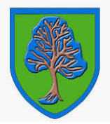
Returning to School
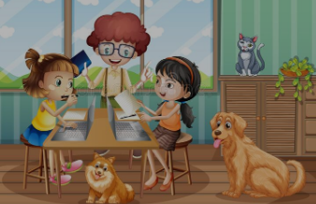
My name is and I am

years old.

My school is called South Parade Primary school.

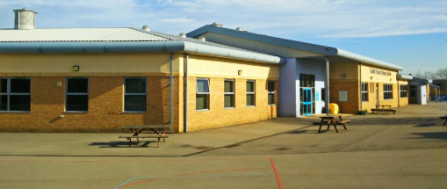
Doing my schoolwork at home has been fun but now it is time for me to go back to school, see some of my friends and do my schoolwork with teachers.

Over the past few months, I have not been at school. I have been staying at home because of coronavirus. During this time, I have been doing my schoolwork with my parents/ carers. Some of my friends from school have also been staying at home. This has been to keep me and my friends safe from coronavirus.
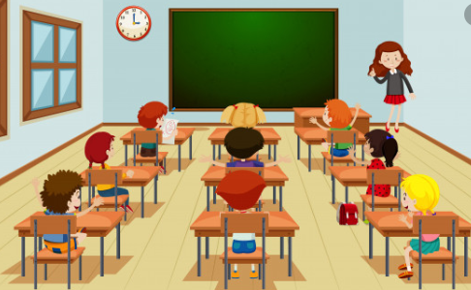

Returning to School
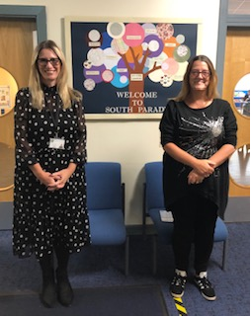
My teachers and friends will be happy to see me back at school. When I go back, some things will be different. This is to keep me safe. I might find the changes difficult at first but my teacher will be there to help me. Everyone finds change hard. This is OK.
- Breaktimes and lunchtimes might be at different times. I might be eating my lunch in the classroom and playing out with the children in my class.
- I will be returning to school in my new class with my new teacher but all the children will be the same.
- I must keep washing my hands for at least 20 seconds.

- If I am going to sneeze or cough, I must do this into a tissue then put the tissue in the bin and wash my hands.
- I must try to stay two metres away from my friends and teachers.
All of the staff at school will help me to adjust to the new rules and routines. This is Mrs Fowles and Mrs Banks. They will help me with any of my worries and anxieties.

Going back to school will be fun. I must try to remember that
the changes are to keep me safe. My teachers will be proud of me for trying to remember what I need to do to keep safe at school.

