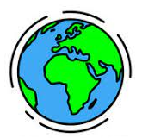

Prior Learning

Previously we have learnt about...

Intent

- The Earth is made up of layers. The top layer, the Earth’s crust, consists of large slabs of rocks, called tectonic plates.
- The plates move as the hot mantle flows beneath them which causes earthquakes and leads to volcanoes erupting.
- Earthquakes are measured on the Richter scale. They can cause devastating damage to buildings, roads and land.
- When volcanoes erupt they spew out lava. This is a very hot liquid that destroys anything in its path.

How does the Earth’s structure cause earthquakes and volcanoes?
What are the features of Volcanoes and Earthquakes?
Why and where do volcanoes and earthquakes occur?

In Early years, we learnt all about Wild things.
In Year 2, we learnt about what a wonderful world the Earth is.

Key Questions
We are Geographers learning about Angry Earth

tectonic plates | Large pieces of rock that move and float on the mantle.
volcano | An opening in the Earth's surface where magma can come out of.
rainforest | A tall, dense forest that receives lots of rain every year.
ring of fire | A chain of volcanoes surrounding the Pacific Ocean.
dormant | Not active but capable of becoming active.
eruption | When gas and molten lava is released into the atmosphere.
fault line | The edge of the tectonic plates.
lava | hot, liquefied rock that flows from a volcano.
magma | molten rock that is found below the earth's surface
mantle | Layer of the earth made of molten material.
Richter scale | System used to measure the size of an earthquake


Key Vocabulary

- The majority of the Earth’s volcanoes are found in the Pacific, in the ‘Ring of Fire’, which is an area where most earthquakes also take place.
- Tornadoes form when warm, humid air collides with cold, dry air.
- Tsunamis are giant waves caused by earthquakes of volcanic eruptions under the sea.

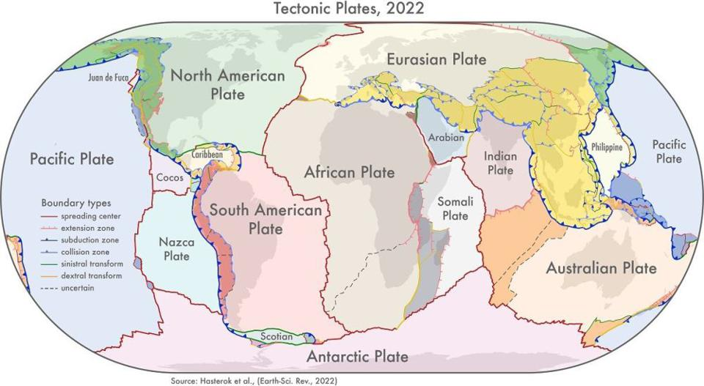

Intent

Career Aspirations
Weather broadcaster
Meteorologist



