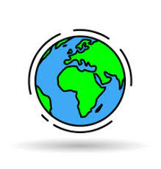

**Key Questions:**

**How does the climate impact the life of an area?**

**We are Geographers learning about biomes and climate zones**



**Prior Learning**

Previously we have learnt about...

Previously we have learnt about...

Y1 Wonderful Weather

Y2 What a Wonderful World

Y3 South America – Amazon and Rainforests

Y5 Marvellous Mountains

**Intent**

|  |  |
| --- | --- |
| Biomes | * The position of Earth in space affects climate. |
|  |
|  |

|  |  |
| --- | --- |
| Climate | Long term weather patterns. |
| Climate zone | A climate zone is an area that has its own distinct climate. Climate zones may have their own type of vegetation and wildlife. Climate zones are arid, Mediterranean, temperate, tropical and polar. |
| Precipitation | Rain, hail, fog, sleet, snow. |
| Weather | Day-to-day temperature, wind, rainfall, etc. |
| Vegetation belt | A vegetation belt is the plant life within a biome. |
| Biome | Biomes are communities of plants and animals that have adapted common characteristics, in order to survive in a certain environment and climate. |
| Latitude | The angular distance of a place north or south of the earth’s equator. |
| Northern Hemisphere | That half of the earth lying north of the equator. |
| Southern Hemisphere | That half of the earth lying south of the equator. |
| Axis | An imaginary line about which the Earth revolves once every 24 hours. |
|  |  |
|  |  |



**Key Vocabulary**

**Intent**

|  |  |  |
| --- | --- | --- |
| **The World’s Climate Zones:** | **Temperate (no extreme weather with rainfall throughout the year), e.g. London in Britain** | **Arid (hot and dry), e.g. Cairo in Egypt.** |
| **Polar (a dry climate with very low temperatures), e.g. Nuuk in Greenland.** | **Mediterranean (hot, dry summers and cool winters) e.g. Servile in Spain.** | **Tropical (high temperatures all year round with lots of rain), e.g. Manaus in Brazil.** |

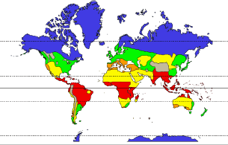

Arctic Circle 66.6˚N

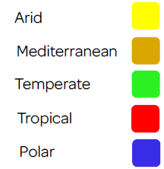

Topic of Cancer 23.4˚N

Equator 0 ˚

Tropic of Capricorn 23.4˚S



Antarctic Circle 66.6˚S