**We are Historians learning about Benin AD 900 – 1900**

**Which key events led to the rise and fall of Benin and what were the consequences?**

Intent

Previously we have learnt about...

the struggle for power between the Anglo-Saxons and Vikings. This was taking place as the kingdom of Benin was developing.

In Year 4, we looked at an empire – The Roman Empire.

**Prior Learning** 

**Intent**

**Key Questions**

* By studying Benin, which is now modern-day Nigeria, it can challenge preconceived attitudes of what Africa was/is like and it can give an understanding of the British influence on other parts of the world.
* At first, the Edo people lived in small family groups, but gradually these developed into a kingdom.
* There are three main periods: Early Era - villages grew into a kingdom ruled over by Ogiso. In Britain, the Anglo-Saxons and Vikings struggled for power and there was the Norman conquest. In South America, the Mayan were building a great civilization. Golden Era – the turning point was the trading of goods including bronzes and slaves with Africans/ Europeans under the leadership of the Oba. The Period of Decline – this was partly caused by civil war and the end of slavery.
* Africa and Britain had strong oral tradition. In Britain, there are also written and pictorial accounts. There are different versions of the same event such as the Eweka story because people telling the stories had different beliefs, e.g. a belief in heaven, a belief in magic. The same story may differ because only one side of the story is being told, e.g. The Bayeux Tapestry that tells the events at The Battle of Hastings in 1066 from the Normans point of view.

|  |  |
| --- | --- |
| Ogiso | The title used by the early rulers of Igodomigodo that later became the Benin kingdom. It means ‘kings of the sky’. It is thought that there were around 31 Ogiso rulers. |
| Edo | The people who lived in the rainforests of West Africa and then the kingdom of Benin. |
| Oba | The title used by Eweka and subsequent rulers instead of Ogiso. |
| civil war | A war between people of the same country. |
| era | A period of time that is joined by cultural/historical factors. |
| turning points | A moment when a decisive change occurs. |
| oral traditions | Remembering things by telling stories, not writing them down |
| Benin bronzes | A collection of intricately-worked sculptures and plaques in bronze, ivory, ceramic and wood that decorated the royal palace of the Kingdom of Benin. |
| indigenous people | Being the people or animals that originally lived and may continue to live in a particular country or region. |
| British Empire | The British Empire is a term used to describe all the places around the world that were once ruled by Britain. |
| valid reasons | Reasons based on truth, fact, or logic. |
| Queen Victoria | The queen of the United Kingdom of Great Britain and Ireland from 1837 to 1901. The ruler of the British Empire. |

**Key Vocabulary **

**Intent**

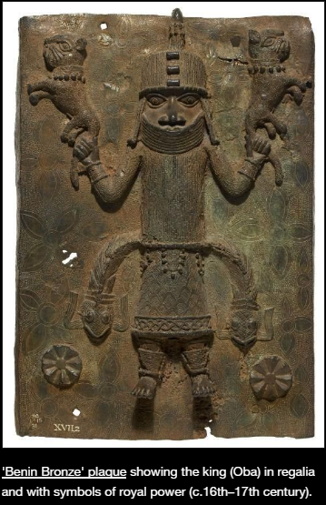

* Bronze art, which Europeans did not think could have been made by Africans as it was produced with such skill, only really tell us about the Oba, beliefs and information about things that were happening, e.g. traders. It does not tell us about everyday life.
* In 1897, the British army invaded. It became part of the British Empire because they wanted the natural resources (palm oil and rubber). People had/have different views about the fairness of this attack.
* There are arguments for and against returning the Benin Bronzes, e.g. they were looted from Benin; Britain should not profit from something that they do not rightfully own; Museums in Nigeria have bronzes so they do not need more; The British Museum is visited by many people so more people get to see this remarkable culture.

