|  |
| --- |
| L.O- To count in tens |
| I can count in 10s (multiples of 10) |
| I can count in tens from any given number |

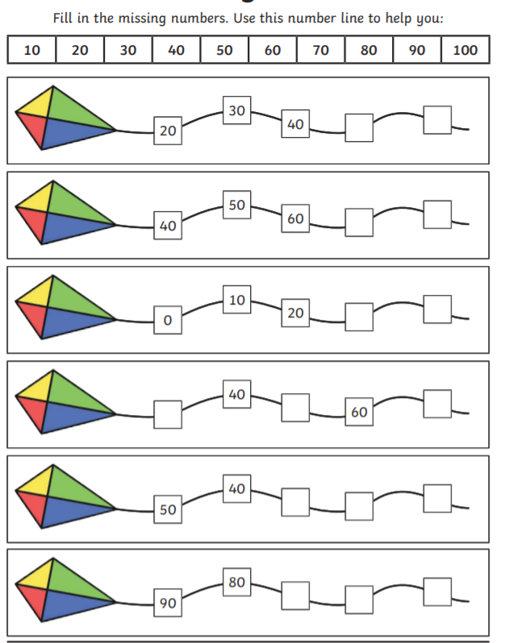

1. Ten more than 60 is ________________________
2. Ten more than 10 is ________________________
3. Ten less than 79 is ________________________

39, 49, 59, _____, _____

18, 28, 38, _____, 58, 68

91, 81, 71, 61, ______, _______

65, 55, 45, 35, _____, 15