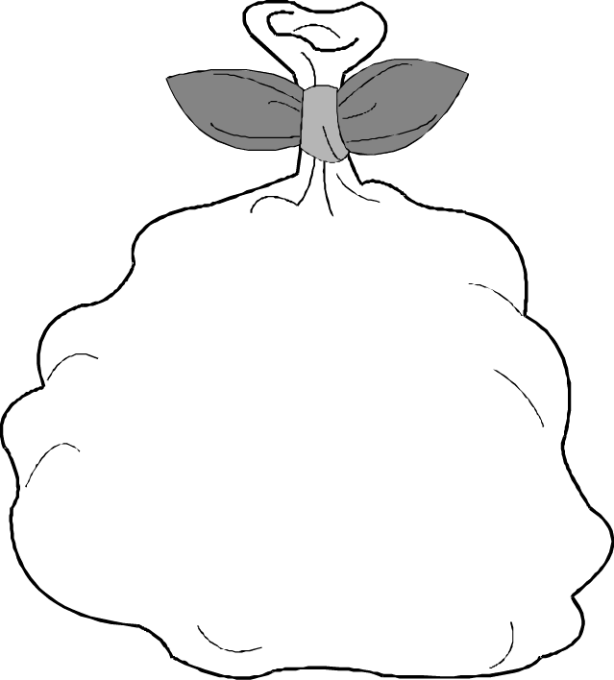

There are 10 sweets in a bag.

How many sweets in 2 bags?

How many sweets in 3 bags?

How many sweets in 5 bags?

How many sweets in 8 bags?

How many sweets in 10 bags?

How many sweets in __ bags?

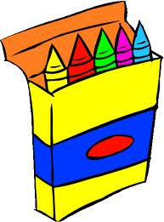
There are 5 crayons in a box.

How many crayons in 2 boxes?

How many crayons in 4 boxes?

How many crayons in 5 boxes?

How many crayons in 7 boxes?

How many crayons in 10 boxes?

How many crayons in __ boxes?


There are 2 flowers in a pot.

How many flowers in 2 pots?

How many flowers in 3 pots?

How many flowers in 5 pots?

How many flowers in 6 pots?

How many flowers in 10 pots?

How many flowers in __ pots?

