South Parade Primary School



PSHRE Policy
(Personal, Social, Health and Relationships Education)




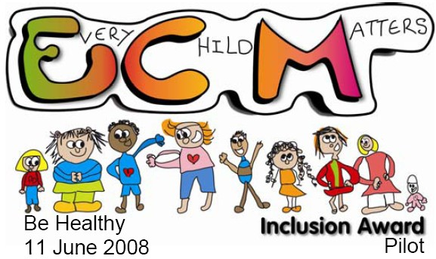


PSHRE Policy

Contents

- Aims………………………………………………………………………………………………………………………………….. 1
- Statutory requirements…………………………………………………………………………………………………….. 1
- Policy development…………………………………………………………………………………………………………... 1
- Curriculum……………………………………………………………………………………………………………………….... 2
- Definition…………………………………………………………………………………………………………………………..… 2
- Delivery of PSHRE………………………………………………………………………………………………………………... 2
- Roles and responsibilities………………………………………………………………………………………………….... 4
- Parents’ right to withdraw………………………………………………………………………………………………….. 4
- Monitoring arrangements…………………………………………………………………………………………………… 5
Appendix 1: Curriculum map………………………………………………………………………………………………. 6
Appendix 2: By the end of primary school pupils should know……………………………………………. 7
Appendix 3: Parent form: withdrawal from sex education within RSE…………………………………. 9

- Aims

The aims of PSHRE at our school are to:
- Provide a framework in which sensitive discussions can take place
- Prepare pupils for puberty, and give them an understanding of sexual development and the importance of health and hygiene
- Help pupils develop feelings of self-respect, confidence and empathy
- Create a positive culture around relationships
- Teach pupils sensitively and in an age appropriate way, whilst taking into account our school ethos and values

- Statutory requirements
The government published the new curriculum for:
Relationships, Sex Education (RSE), and health education. This includes relationships and health education for primary schools and sex education for secondary schools. This guidance was statutory from September 2020, however due to extenuating circumstances they gave school until the beginning of summer term 2021 to begin teaching this.

https://www.gov.uk/government/publications/relationships-education-relationships-and-sex-education-rse-and-health-education

Although it is not statutory to deliver sex education in primary schools, in the government guidance it states that it will be for primary schools to determine whether they need to cover any additional content on sex education to meet the needs of their pupils. Many primary schools (including ours) already choose to teach some aspects of sex education and will continue to do so, although it is not a statutory requirement.

- Policy Development

- Mrs E Fieldhouse (PSHRE lead) alongside senior leaders, based on research of best practice, have developed the policy.
- The scheme of work has been shared with all staff who will be required to deliver this curriculum and staff have access to training and development through the PSHE association and Twinkl Life.
- Parents have been given the opportunity to provide feedback

- Curriculum

Our curriculum is set out as per Appendix 1.
School use the PSHE Association’s Programme alongside the Twinkl Life scheme to deliver all aspects of the PSHRE programme.
We have ensured our curriculum takes account of the age, needs and feelings of our pupils.
If pupils ask questions outside the scope of this policy, teachers will respond in an appropriate manner so they are fully informed.

Elements of puberty are taught in KS2 within the science curriculum and teaches children about the physical and biological changes of puberty. This is statutory.

- Definition

RSE is about the emotional, social and cultural development of pupils, and involves learning about relationships, health, sexuality, healthy lifestyles, diversity and personal identity.

RSE involves a combination of sharing information, and exploring issues and values.

RSE is not about the promotion of sexual activity.

- Delivery of PSHRE curriculum

RSE is taught within the personal, social and health education curriculum. Biological apsects of RSHE are taught within the science curriculum, and other aspects are included in religious education (RE).

Lessons will be taught from the Twinkl Life programme which covers three core themes over the year with three topics per half term: Health and Wellbeing; Relationships; and Living in the Wider World. This approach allows different year groups to work on similar themes at the same time, building a spiral programme year on year, whilst offering flexibility in terms of medium term planning.

At each stage of learning, the needs of all pupils, including SEND, will be addressed prior to the delivery of lessons. Teachers will plan for all pupil groups, ensuring each lesson has appropriate content and resources to support all children.

Relationships education focuses on teaching the fundamental building blocks and characteristics of positive relationships including:
- Families and people who care for me
- Caring friendships
- Respectful relationships
- Online relationships
- Being safe

These areas of learning are taught within the context of family life taking care to ensure that there is no stigmatistation of children on their home circumstances (families can include single parent families, LGBT parents, families headed by grandparents, adoptive parents, foster parents/carers amongst other structures) along with reflecting sensitively that some children may have a different support structure of support around them (for example: looked after children or young carers).

Sex Education

We believe that an effective PSHRE programme provides pupils with the critical knowledge that they need to understand and manage the emotional and physical changes of growing up. It is seldom purely the biological changes of growing up that concern pupils, which is why science lessons need to be balanced with sex and relationships education, which deals with the social and emotional elements of growing up.

These lessons will be delivered as discrete lessons and parents will be informed when they are taking place (please see section 8 on parents’ right to withdraw from these lessons). These lessons are outlined the the curriculum planning document and take place within the ‘Growing Up’ unit in year 6.

Elements of puberty are taught in KS2 within the science curriculum and teaches children about the physical and biological changes of puberty from a science perspective. This is statutory.

Sex education that is in addition to what is covered in the science curriculum:

Year 6:
- Identify the links between love, committed relationships and conception
- What sexual intercourse is, and how it can be one part of an intimate relationship between consenting adults
- How pregnancy occurs i.e. when a sperm meets an egg and the fertilized egg settles into the lining of the womb
- That pregnancy can be prevented with contraception
- About the responsibilities of being a parent or carer and how having a baby changes someone’s life

- Roles and responsibilities

- The governing body will approve this policy and hold the head teacher to account for its implementation
- The Headteacher (alongside deputy head) is responsible for ensuring that PSHRE is taught consistently across the school, and for managing requests to withdraw pupils from non-statutory components of the curriculum
- Staff do not have the right to opt out of teaching PSHRE.
- All teachers are responsible for the delivery of the curriculum.
- Staff are responsible for:
- Delivering the curriculum in a sensitive way
- Modelling positive attitudes
- Monitoring progress
- Responding to the individual needs of pupils
- Responding appropriately to pupils whose parents wish them to be withdrawn from non-statutory elements

- Parents right to withdraw

Parents do not have the right to withdraw their children from relationships or health education.

Parents have the right to withdraw their child from the non-statutory/non-science components of sex education within RSE which are outlined above (Y5 & 6 only).

Requests for withdrawal should be put into writing using the form found in Appendix 3 of this policy. This will be sent out when we inform parents in Y6 when this will be taught.

Alternative work will be given to pupils who are withdrawn from sex education.

- Training

Staff training is including in our continuing professional development calendar.

Specialist visitors such as school nurses or health professionals will also be invited in to deliver some aspects of the curriculum.

- Monitoring arrangements

The planning and delivery of RSE is monitored by the PSHRE lead, Mrs E Fieldhouse through: pupil voice, discussions with staff, CPD, work scrutinies and learning walks.

Class teachers as part of our internal assessment systems monitor pupils’ development in PSHRE.

This policy will be reviewed annually by the PSHRE lead. At every review, the policy will be approved by the governing body and the head teacher.

Appendix 1 – PSHRE
LONG TERM OVERVIEW
(See following page)

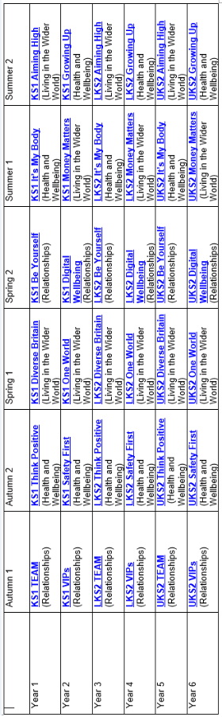

Appendix 2:
Statutory government
guidance
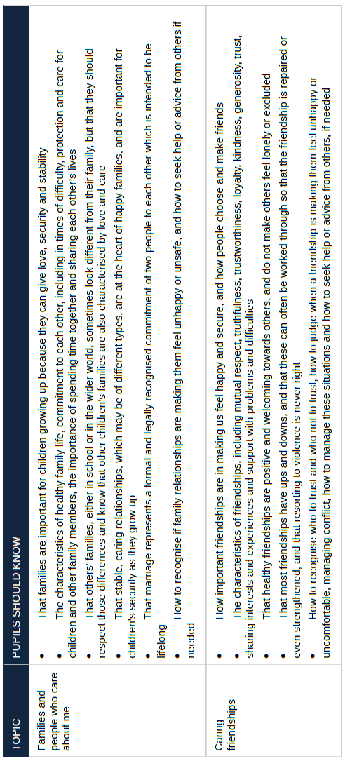

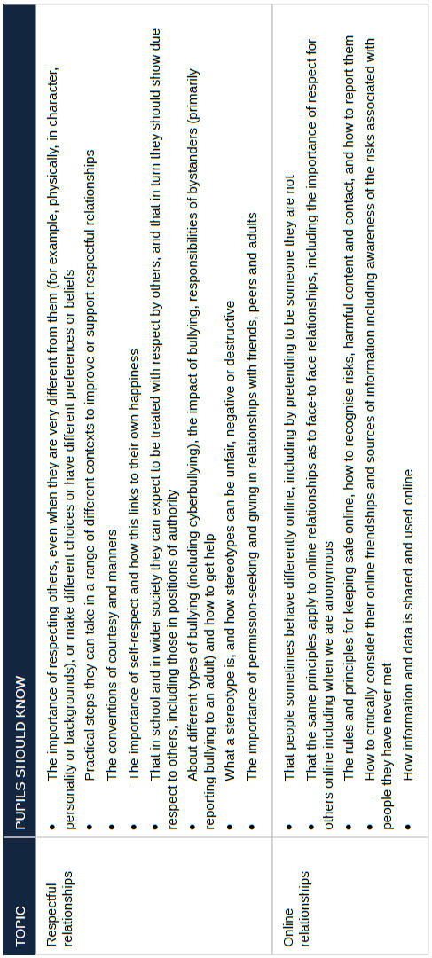

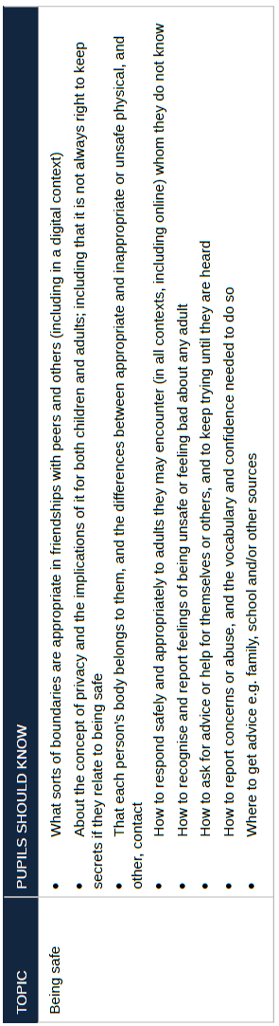

Appendix 3: Parent form: withdrawal from sex education.
ONLY TO BE COMPLETED AFTER LETTER SENT OUT PRIOR TO THIS BEING TAUGHT
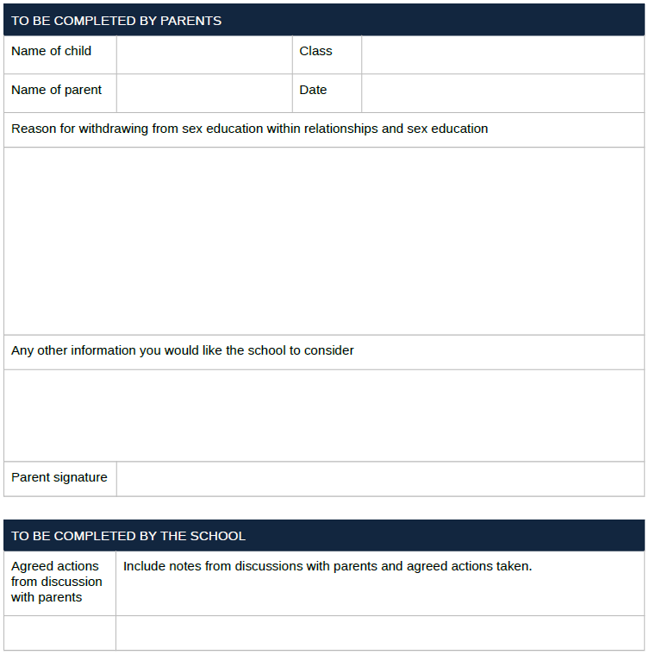
RELEVANT TO Y6 ONLY

