**South Parade Primary School**

**Pupil premium strategy statement**

**2018-2019 REVIEW**

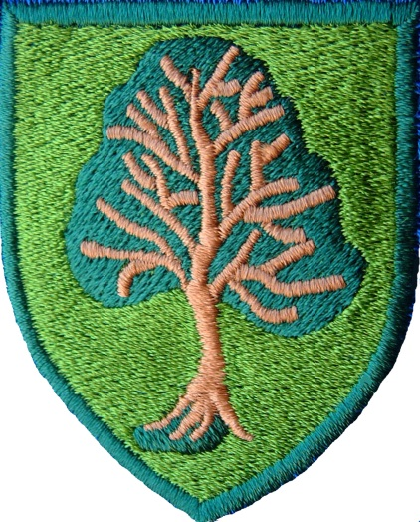

|  |  |  |  |  |
| --- | --- | --- | --- | --- |
| **Review of expenditure**  **2018-2019 Total funding received: £111,440** | | | | |
| **Desired outcome** | **Chosen action/approach** | **Estimated impact:** Did you meet the success criteria? Include impact on pupils not eligible for PP, if appropriate. | **Lessons learned**  (and whether you will continue with this approach) |  |
| Increase the number of PP children who are meeting end of year expectations in Reading | 1. A targeted Reading Intervention Breakfast Club (Early Birds) to engage pupils in their learning, and improve attendance for children where persistent lateness is an ongoing issue  2. Targeted reading intervention after school club (Night Owls) to support children with their reading and to target pupils who are unable to attend breakfast club (childcare arrangements etc.)  3. A new home reading scheme to be bought and launched in school for whole school  4. To hold a reading engagement evening with Y5 and Y6 pupils and parents in conjunction with the high school. To hold a weekly drop in reading café where y5, 6 and 7 pupils read and network  **5.** To provide a Toe by Toe specialist TA two afternoons per week to work with targeted pupils | Pupil progress meetings – data analysed for PP children and tracked. Any pupils not making progress identified and targets adjusted. Support from JM (UKS2 Lead) for TAs working with those pupils in Early Birds and Night Owls  Parent feedback positive. Children have responded well to new books.  Love of reading continues to grow.  The reading café didn’t go ahead due to space and other demands on the curriculum.  Pupils involved in toe-by-toe sessions tracked through termly pupil progress meetings | Termly meeting with UKS2 lead successful. Increase to half termly.  Meetings with EF and JS re groupings and progress, target plans – set these in diary for every half term and include on monitoring calendar.  Share at the half termly meetings with other Early Birds staff.  EF + NI (T+L lead) to build in observations of Early Birds sessions.  Adding books to the reading scheme that match phonics phase. Children to take home one ORT book and one phonics book. New books will need to be purchased to supplement the ORT scheme.  For 2019-2020, more input into phonics and ensuring early spelling/phonics improved. |  |
| Increase the number of PP children achieving higher level maths  To increase maths outcomes for PP pupils | 1. To set up weekly maths tuition group targeted at higher level maths pupils, allowing them to be taught the higher level curriculum 2. To target pupils to attend extra tuition groups weekly (some twice weekly) | Higher number of PP pupils achieving in maths.  Progress levels increased. | To continue to work with HA PP pupils to ensure highest attainment and progress as possible. |  |
| Increased attendance rates for pupils eligible for PP. | 1.To target and invite PA children and regular late attenders to attend Early Birds.  2.Head teacher/ Learning Mentor/BM to produce a half termly report on attendance to be shared at the PP working group  3.If families do not engage with absence policy (first response systems) then Learning Mentor to become involved with family to overcome barriers (alongside EWO)  4.To introduce reward systems into FS (teddy for Rec, children get to take home etc.)  5.To set up an attendance working group   1. To set up reward systems for attendance throughout school (£5 vouchers, class trophy) | Improved attendance for PA pupils, able to operate first response systems sooner so children if late, not as late.  Attendance working group meet half termly to scrutinise attendance figures and introduce new systems  LM works with families alongside EWO  Reward systems successful – feedback from parents and pupils. | Continue with PA pupils being targeted for Early Birds attendance.  Rewrite the letter that is sent to Early Birds pupils with sporadic attendance. This to form part of the discussion when EWO involved with families. |  |
| **Remove barriers to learning**; support and build pupil confidence and behaviour; support pupils’ social and emotional well-being | 1. A full time Learning Mentor working to support children and families to remove barriers to learning  2. Appointment of Senior Lunchtime Supervisor who will oversee lunchtime provision and will liaise directly with the Learning Mentor  3. Speech and Language therapist to work with children where parents have not committed to taking them to external appointments  4. To provide support for children who have learning needs combined with behavioural issues  5.To provide intervention to support social and emotional needs of pupils  6.Provision of school uniform, residential visits and school trips  7.To support pupils with mental health issues | Case studies to evidence LM impact  Behaviour records to show less incidents  Training for Lunchtime supervisors  Pupils who may not have attended external appointment attending SALT sessions in school time  Children identified through provision mapping and accessing appropriate interventions  Case studies show impact  Tracked in each year group through pupil progress meetings | More lunchtime equipment to help reduce behavioural incidents  Continue with SALT  More lunchtime focus groups – based on developing social skills and in turn reducing behavioural incidents  X 3 staff during lunchtimes 19-20 |  |
| **EYPP** |  |  |  |  |
| **Remove barriers to learning**; To identify pupil needs prior to them starting in the Early Years setting  To improve maths outcomes for pupils who are exceeding | To conduct home visits, meeting parent and child in own environment and identifying any issues, gathering key information which will then inform future planning  AK to develop maths opportunities for pupils within EYFS setting. This will form part of the action plan for EYFS. | Home visits successful – early intervention and identification of SEN pupils meaning paperwork completed earlier and support allocated sooner.  Maths audit completed and actions identified and implemented across FS unit for 19-20 | Continue home visits for EY pupils.  Maths actions to be implemented in 19-20. Maths to remain as EY PP spend. |  |
| **Additional Information re PP funding**  10% of SENCO Salary  10% of Deputy Salary  2% of admin officer  Speech and Language £5000  Educational psychologisy 4K | | | | |