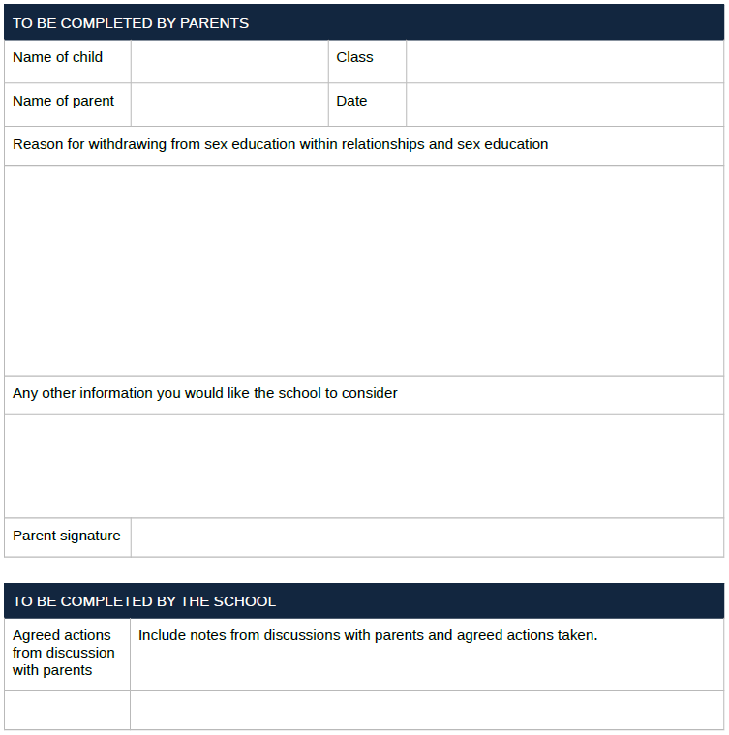**Parent/carers right to withdraw.**