Safeguarding at South Parade Primary School
What is safeguarding about?
At South Parade Primary School, all of the adults around you think that your health, safety and welfare are very important. In our school we respect our children and want to keep you safe and help to protect your rights.
We do our best to help you to make good progress in your school work and to be happy.
We teach you how to recognise risks in different situations and how to protect yourselves and stay safe. That means staying safe online too.

How will we try to protect you?
- We try to provide a safe environment for you to learn and play in.
- We want to ensure that you remain safe, at home as well as at school.
- We think it is important for you to know where to get help if you are worried or unhappy about something.
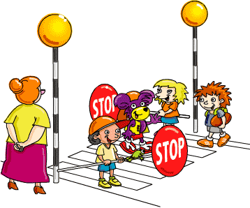

If you need to talk – we will listen!
- You can talk to any adult in school, whoever you feel comfortable to talk to
- The adults who are specially trained in safeguarding children and keeping them safe are: Mrs Peace, Mrs Fieldhouse and Mrs Banks
- It is Mrs Banks’ special job to keep you safe firstly by talking things through – you can talk to her if you are worried.
- Put something in the ‘I need to talk’ box.
- See the Keeping me Safe tab on our school website.
- Tell a friend and then go with your friend to tell an adult.
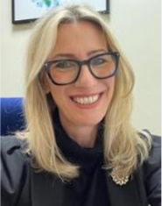
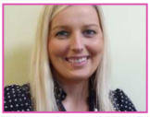
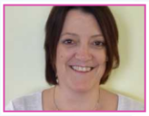
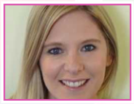

Mrs Fowles
Mrs Banks
Mrs Fieldhouse
Mrs Peace

Don’t keep it a secret if someone is:
- Bullying you;
- Saying funny things to you that you do not like or which upsets you;
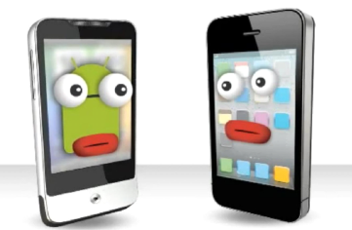
- Touching you in a way that makes you feel uncomfortable;
- Trying to give you tablets, cigarettes, drugs or alcohol;
- Hitting you or hurting you;
- Someone gives you a present and it doesn’t feel right;
- Taking your things;

- Sending unkind messages on the internet or to your phone.

