Review of Sports Funding 2017-2018
As ever, PE and sports provision have figured highly in the culture of South Parade Primary School. Children across all key stages have benefitted from the provision provided by the Sports Funding.
Large numbers of children have continued to attend the after school clubs and all year groups have benefitted from high quality coaches leading the PE lessons – this has had a very positive impact on the continuing CPD of staff members.
All after school clubs were inclusive to both boys and girls and to children with special needs.
Sports profile within school is also evident at dinner time. Children are encouraged by the sports coach to take part in team games and the dance coach has managed to involve the whole playground in danceathons!

South Parade has also benefitted from links across the community. Years 2/3/4/5 have been part of the SkyTry RL programme which has been delivered by Wakefield Trinity. And Years 2/3/4/5/6 have all taken part in tournaments/taster sessions as part of the EOCT. Ossett Academy have been instrumental in providing some of these opportunities which have included: trampolining, rounders, scatterball, swimming galas etc.

Years 5 and 6 have taken part in football matches/tournaments and netball fixtures against local primary schools. We now have new football/rugby kits and netball bibs.

Year 6 were lucky enough to be given a chance to play Wheelchair Basketball. Steve Greatorex from Wakefield Whirlwinds provided free sessions and in return the Y6 children raised £50 to assist in purchasing new tyres for the wheelchairs.

South Parade Healthy Week was again a great success. A whole variety of sporting activities were organised for all the children and during the course of the week they took part in up to nine different activities (karate, tri golf, athletics, bootcamp, rugby, dance, bochia bowling, wheelchair basketball and cricket).

Aspirations
The Sports Funding for 2018-19 will allow all of the provision to continue. High quality curriculum PE lessons led by qualified coaches; teachers developing knowledge and skills; an opportunity to include coaches that can lead sport/dance activities at lunchtimes - and all helping to promote fair play, positive behaviour and a healthy lifestyle that is inclusive to all.

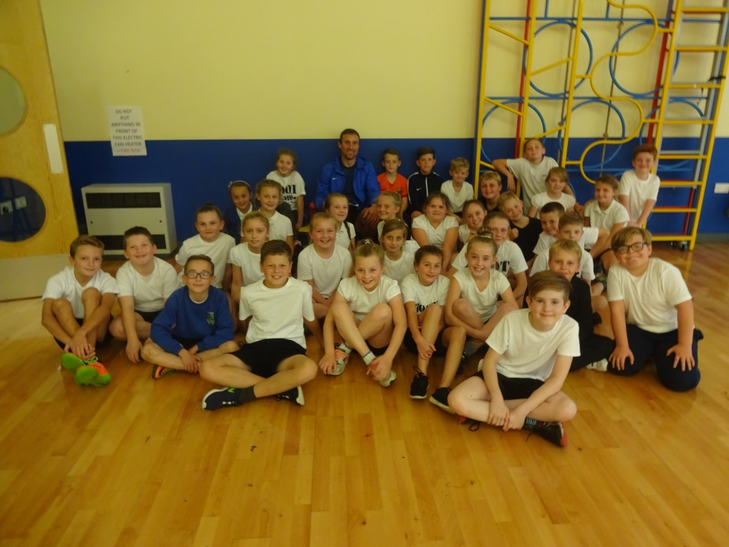

Boot Camp Year 5 and
Year 6
September 2017

South Parade Primary School - Sports Funding 2018 - 2019

South Parade Primary School recognises that all pupils regardless of their background should have equal access to a curriculum which will enable them to reach their potential. The sports funding premium is a Government initiative that targets extra money to all pupils and all schools.

The Government are not dictating how schools should spend this money, but are clear that schools will need to employ the strategies that they know will support these pupils to increase their active participation in sports.

Schools must spend the additional funding on improving their provision of PE and sport, but they will have the freedom to choose how they do this.

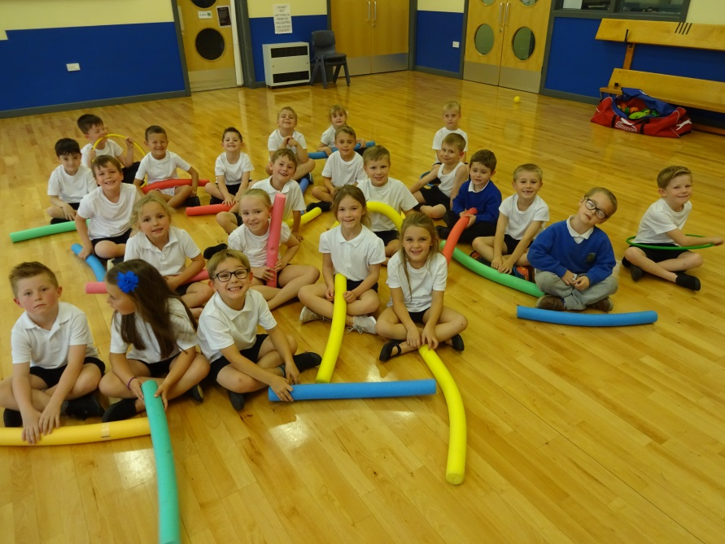

Year 1 and Year 2 Multi Sports
September 2017

Possible uses for the funding might include:

- hiring specialist PE teachers or qualified sports coaches to work with primary teachers when teaching PE
- paying for professional development opportunities for teachers in PE and sport
- providing cover to release primary teachers for professional development in PE and sport
- buying and updating quality materials for PE and sport
- providing places for pupils on after school sports clubs and holiday clubs
- pooling the additional funding with that of other local schools

The Government have allocated funding to all schools to be spent on sports provision. South Parade received £19420 from April 2017 to March 2018. We have used this money to help us provide a comprehensive package of Sport which we offer to all pupils.


Year 5 and Year 6 Football Club
September 2017

Achievements:
- During the last academic year after school sports clubs were accessed every week day – run by professional coaches.
- On some days more than one club was offered.
- All clubs were initially fully subscribed

- Children from all Key Stages have attended
- All children have been given the opportunity to attend – this has included vulnerable/SEN/disabled children
- All children accessed expert coaching during Sports Week
- Various year groups have accessed curriculum support/ professional coaching. This has also provided staff CPD
- KS1 children took part in an inter school competition and transport was provided
- KS2 children took part in inter and intra school tournaments
- Over the last two years as a result of Sport Funding a Y6 PP child has regularly attended on a weekly basis the following after school clubs: football, multisports/bootcamp/cricket. His skills and athletic ability have developed and improved. He is fit and healthy and takes on all challenges offered to him. In class he displays motivation and determination with an intent to improve his learning. He has progressed well in his final year and is endeavouring to do his very best in the end of KS2 SAT’s.

We embrace the benefits of competitive sports, and are proud of the sporting accomplishments that our pupils achieve both through school sports and with our local community sporting teams.
- Priority 1 To further improve teacher confidence in teaching and delivering PE lessons
- Priority 2. To increase pupil access to expert coaching and thereby increase pupil engagement in school sports
- Priority 3. To incorporate expert coaching into the PE curriculum which will bolster CPD

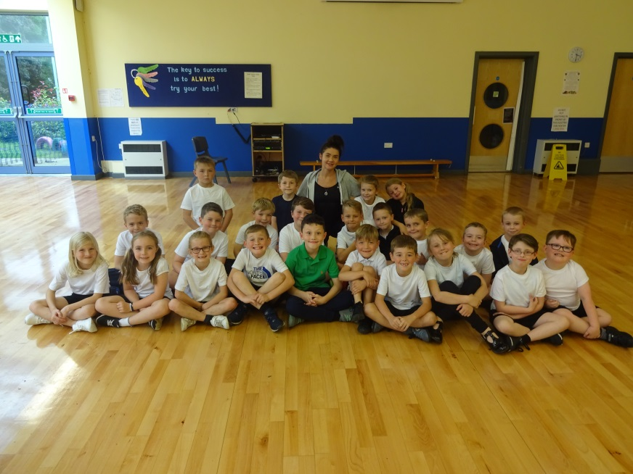
Year 3 and Year 4
Multi Sports
September 2017

Activities offered include:
- Timetabled PE sessions taught jointly by Class teachers and Sports Coach –to include football, rugby, cricket, rounders, basketball, dodgeball, gymnastics, dance etc.
- Intra and inter and School competitions throughout the year – both Key Stages
- After School Clubs every day of the week across both KS1 and KS2, including multi sports, Boot Camp, karate and football.
- Swimming lessons for all Year 5 and 6 pupils and engagement in Galas with other local schools. Excellent instruction led by Samara Bruce from Ossett Academy.
- A comprehensive training programme for KS2 pupils to act as playground sports leaders for our KS1 and Foundation Stage pupils.
- Links to Community Sports Clubs: We actively encourage pupils to extend their sporting skills by directing them to our local sporting clubs through individual talent spotting and through whole group taster sessions.
- Children given opportunity to attend Holiday Clubs at local sports clubs eg Wakefield Trinity and in house Holiday Sports Club during the summer term.
- Themed ‘Healthy Week’ where professional coaches provide a wide and varied range of activities. Each class participating in at least seven sessions – to include wheelchair basketball, games for the visually impaired, football, skipping, basketball, athletics, rugby, karate, multi sports etc.
- School also holds Sports Days where healthy competition is encouraged and winners are celebrated.
- The clubs we link with include: Wakefield Trinity Wildcats, YRFU, Yorkshire Cricket, Local football teams.
- School also links with its neighbouring primary schools and attends mini tournaments organised and provided by Ossett Academy.

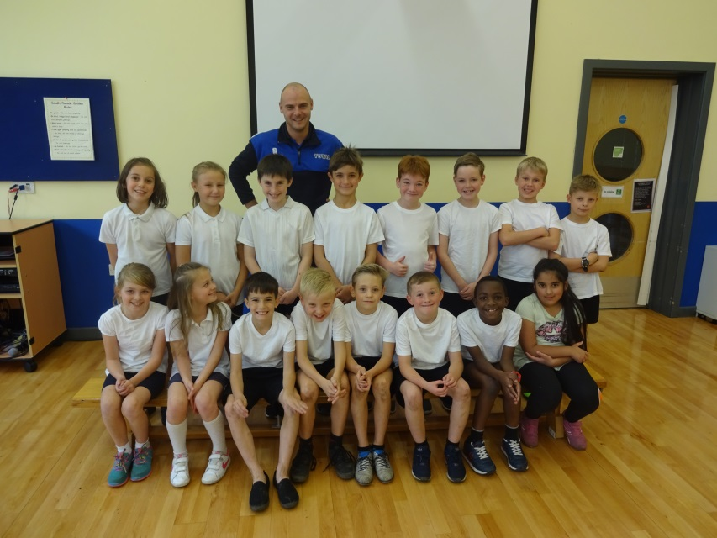

Year 4, Year 5 and Year 6
Multi Sports
September 2017

Meeting national curriculum requirements for swimming and water safety – as of July 2018
What percentage of your current Year 6 cohort swim competently, confidently and proficiently over a distance of at least 25 metres? | 98%
What percentage of your current Year 6 cohort use a range of strokes effectively [for example, front crawl, backstroke and breaststroke]? | 88%
What percentage of your current Year 6 cohort perform safe self-rescue in different water-based situations? | 100%
Schools can choose to use the Primary PE and Sport Premium to provide additional provision for swimming but this must be for activity over and above the national curriculum requirements. Have you used it in this way? | No  Selected children proficient/and  non-proficient children attend end  of KS2 Swimming Gala

Children from Year2/3/4/5/6 attend Karate after school on a Wednesday. This is run by John Tumman. The children pay a weekly subscription.
This is a popular after school club. John is an excellent coach and instills discipline and determination in all of the children he works with. John also provides a day’s coaching during Healthy Week when all of the school get a taste of Karate.

Sports Funding Allocation
2016 – 2017 (Financial Year) | 2017 – 2018 (Financial Year) | 2017-2018 (Financial Year)
£8000 + £5 per pupil | £16000 + £10 per pupil = £19420 | Approx. £19000

Sports Funding 2018 – 2019

Final amount has yet to be confirmed – it is expected to match 2017-2018 funding

The following demonstrates how we intend to use the Sports Funding in 2018-2019
The approx. cost for the 2018-2019 is £18940

Sports funding 2017-2018 | £19,420
Sports Funding 2018-2019 (projected) | £19,280 |  | Provider
Lunchtime sports provision 1hrx3 30 weeks | £3,150 |  | Generation Fit/Bootcamp
Dance curriculum provision 2hr 24 weeks | £1,680 |  | Dance Xplosion
Cricket curriculum provision 2hr 11weeks | £880 | ` | JSCricket
PE curriculum provision 5hr 30 weeks | £5,250 |  | Generation Fit/Bootcamp
Healthy Week | £1,620
Transport costs EOCT minibus | £100
AFTER SCHOOL CLUBS
Mon Mutisports 1hr 30 weeks Aut/Spr/Sum | £1,050 |  | TSS
Tues Mutisports 1 hr 20 weeks Aut/Spr | £800 |  | JSCricket
Tues Cricket 1 hr 10 weeks Summer | £400 |  | JSCricket
Thurs Multisports 1hr 30 weeks Aut/Spr/Sum | £1,200 |  | JSCricket
Thurs Football 1hr 30 weeks Aut/Spr/Sum | £2,100 |  | Mr Shaw/Mr Lewty
Fri Bootcamp 1hr 30 weeks Aut/Spr/Sum | £1,050 |  | Generation Fit/Bootcamp
Total | £19,280

Intention of Spending |  | Proposed Outcomes
*Playground Lunchtime Sports Leaders  Martin Law – one hour x 3 per week  Also Jodie Travis to provide 1 hour per week |  | - Support pupils in providing a strong presence in leading break and dinner duty  - Happy, safe playtimes with high pupil engagement  - Active pupils  - Promotion of different activities  - Positive behaviour  - Organised healthy competition between year groups – and celebrated  - Inclusion of all abilities and gender
*Teaching staff and professional coaches delivering after school sports clubs:  Football  Multi sports  Cricket  Dance  Bootcamp |  | - Increased participation in active sports.  - Specialist coaches with accurate subject knowledge.  - Introduction to new activities.  - Promotion of a Healthy Lifestyle  - Developing leadership, communication and organisational skills  - Team building  - Improve sports provision in the community  - Positive behaviour
Professional sports coaches offering curriculum support in PE lessons  Teaching CPD |  | - Increased participation in active sports.  - Specialist coaches with accurate subject knowledge.  - CPD for teaching staff – more confident and competent  - Introduction to new activities.  - Promotion of a Healthy Lifestyle  - Developing leadership, communication and organisational skills  - Team building  - Positive behaviour
*Funding for professional sports coaches during Healthy Week  *Possible funding to access outside agencies to offer advice and support to children regarding healthy lifestyles eg drug awareness | £1000  £100 | - Increased participation in active sports.  - Specialist coaches with accurate subject knowledge.  - Introduction to new activities.  - Promotion of a Healthy Lifestyle  - Developing leadership, communication and organisational skills  - Staff CPD – more confident and competent  - Team building  - Positive behaviour
*Providing transport for children attending inter school tournament – EOCT minibus | £100 | - Increased participation in active sports.  - Specialist coaches with accurate subject knowledge.  - CPD for teaching staff – more confident and competent  - Introduction to new activities.  - Promotion of a Healthy Lifestyle  - Developing leadership, communication and organisational skills  - Team building  - Positive behaviour
*Purchasing PE equipment – upgrading and replacing  Proposed after school clubs, school year 2018 -2019  Free to all children  Monday – Multi Sports Y1 and Y2 all year  Club places 24 till Dec and then another 24 Spring and Summer  Tuesday – Multi Sports Y5 and Y6 Autumn and Spring  Dance Y3 Y4 Y5 Summer  Cricket Y6 Summer  Club places for all 24 all year  Wednesday – Karate Y3 Y4 Y5 Y6 (only club that charge is applied) very well subscribed  Club places 30 all year  Thursday – Football all year  Multi Sports Y3 and Y4 all year  Club places 30 all year  Friday – Boot camp all year  Club places 30 all year |  | Accessed through annual share of curriculum budget. £200  Number of children attended 2017-18 approx  25 per week all year  20 per week till End of Spring term  24 per week summer term  16 per week summer term  25 per week all year  26 per week all year  25 per week all year  20 per week all year

