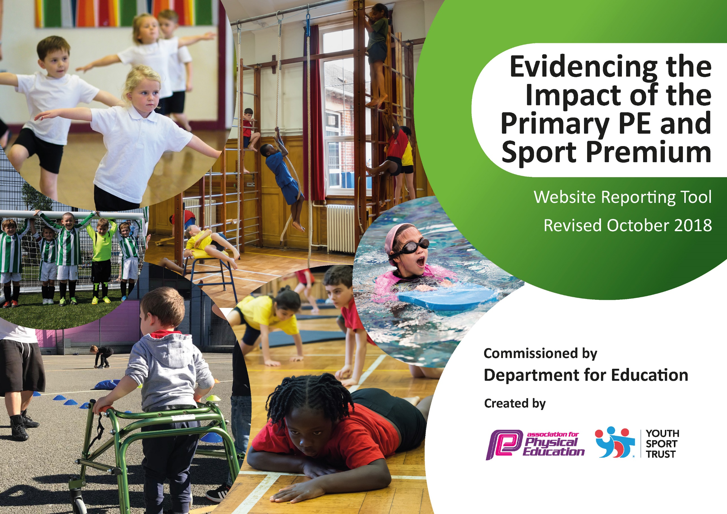
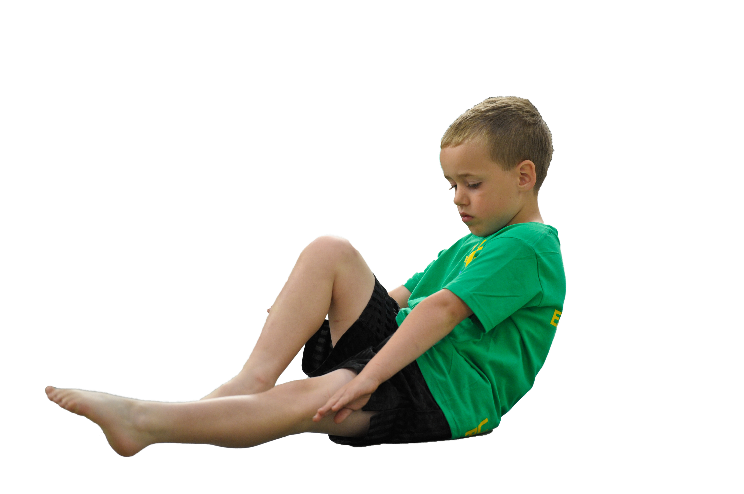
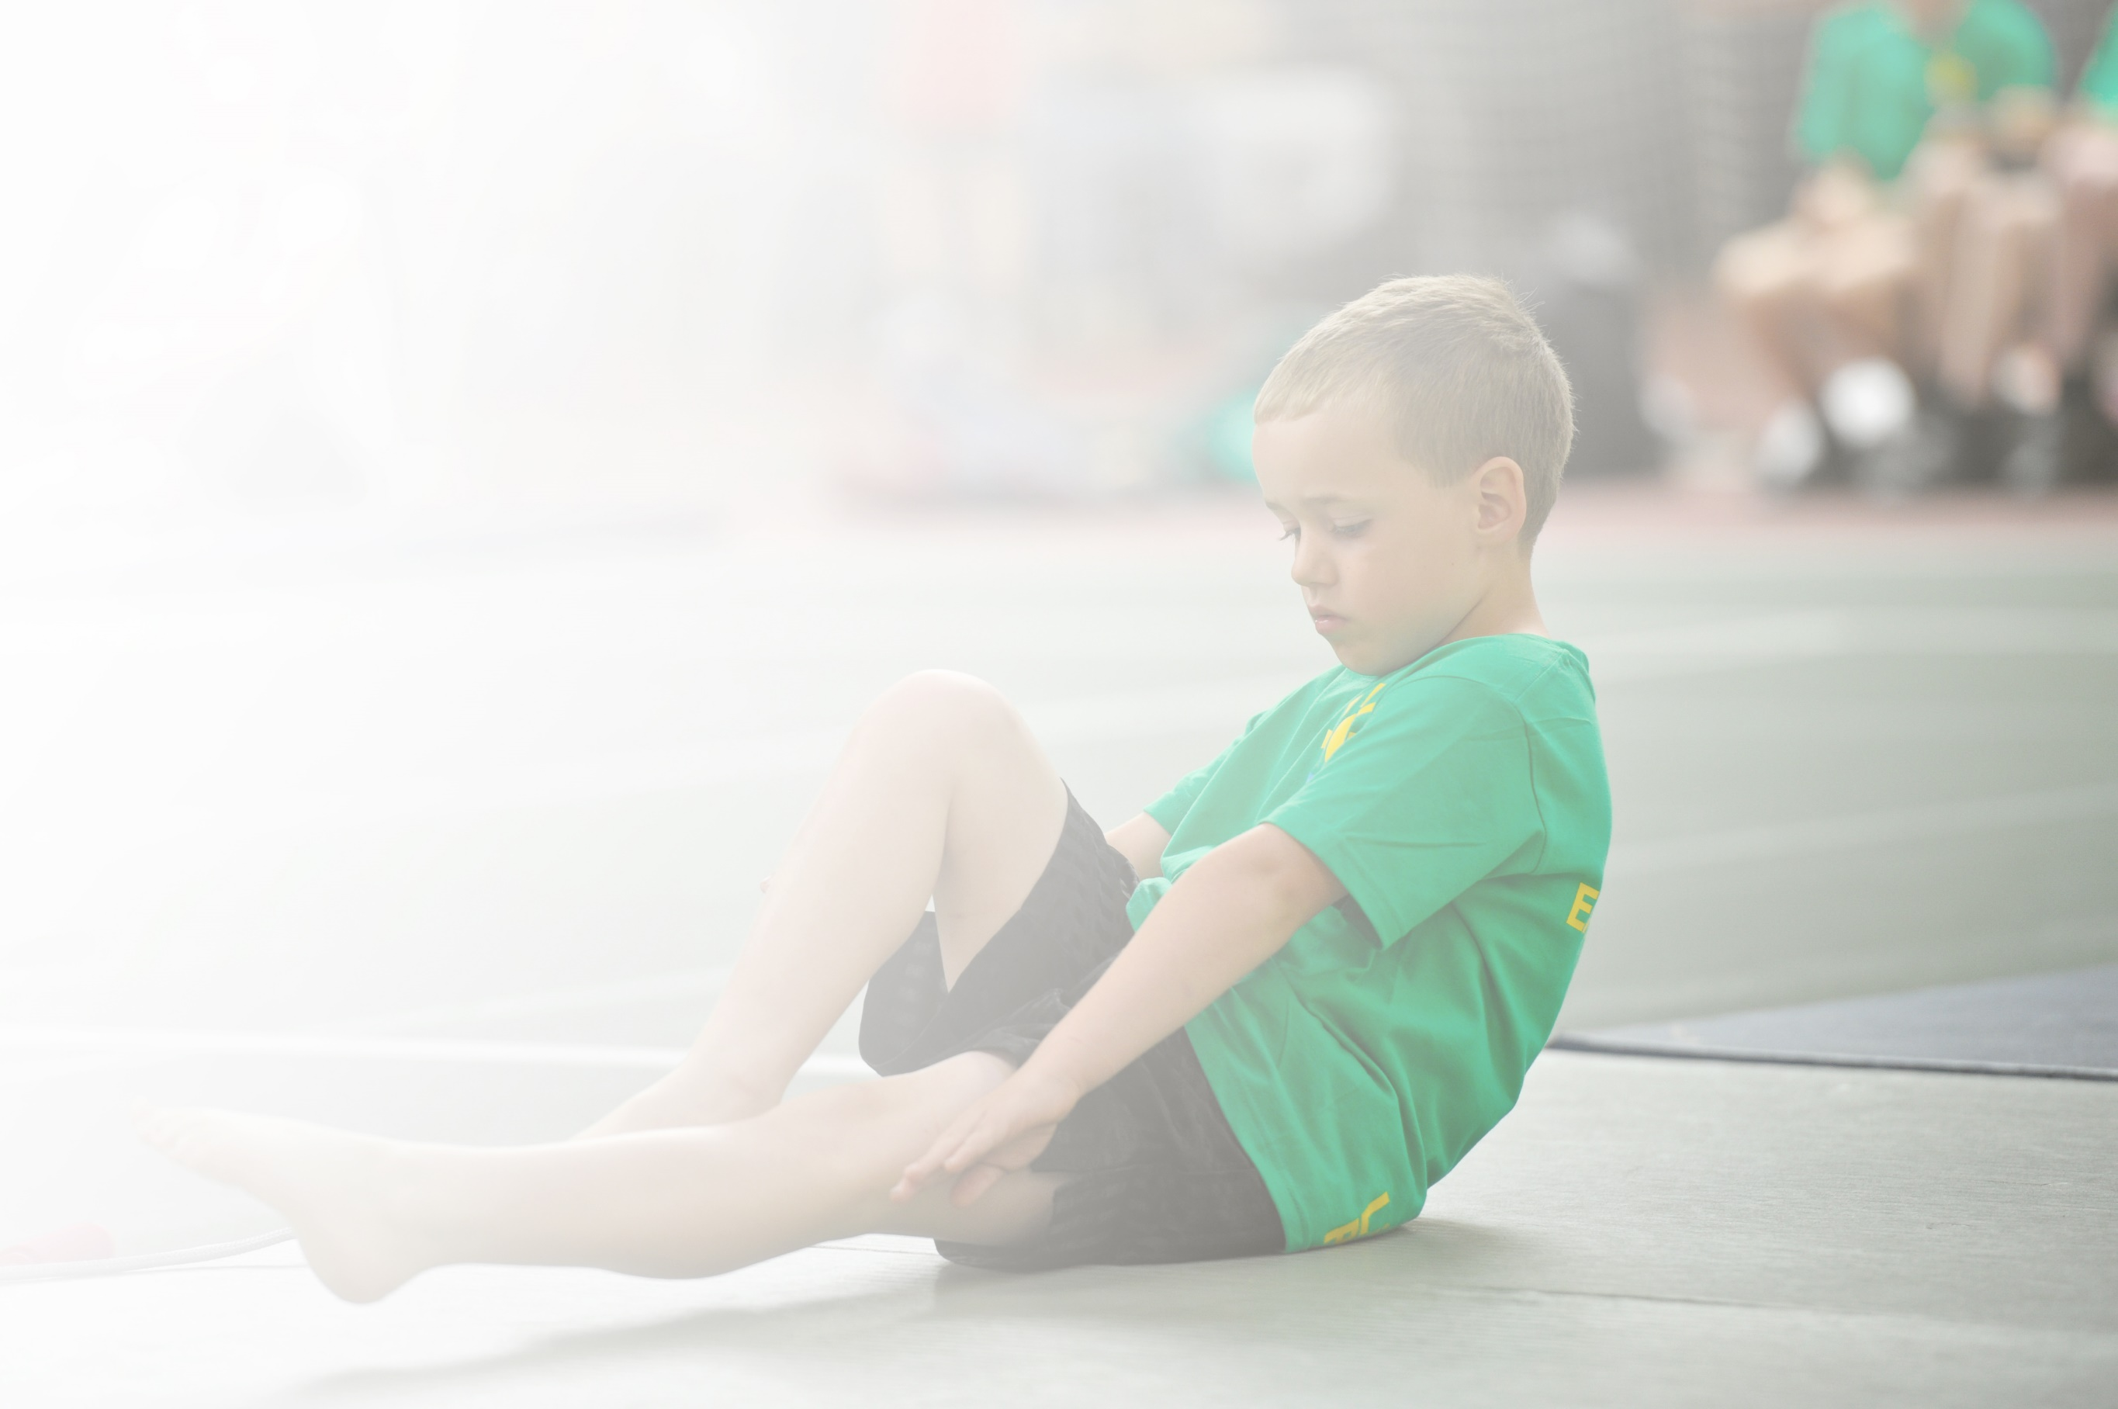
PLEASE NOTE:
IN LIGHT OF THE COVID19 EFFECT ON SCHOOLS, THE CURRENT PLAN IS STRICTLY PROVISIONAL AND MAY HAVE TO BE AMENDED AS THE SCHOOL YEAR PROGRESSES

Schools must use the funding to make additional and sustainable improvements to the quality of Physical Education, Sport and Physical Activity (PESPA) they offer. This means that you should use the Primary PE and Sport Premium to:

- Develop or add to the PESPA activities that your school already offer
- Build capacity and capability within the school to ensure that improvements made now will benefit pupils joining the school in future years

Please visit gov.uk for the revised DfE guidance including the 5 key indicators across which schools should demonstrate an improvement. This document will help you to review your provision and to report
your spend. DfE encourages schools to use this template as an effective way of meeting the reporting requirements of the Primary PE and Sport Premium.

We recommend you start by reflecting on the impact of current provision and reviewing the previous
spend. Under the Ofsted Schools Inspection Framework, inspectors will assess how effectively leaders use the Primary PE and Sport Premium and measure its impact on outcomes for pupils, and how effectively governors hold them to account for this.

Schools are required to publish details of how they spend this funding as well as on the impact it has on pupils’ PE and sport participation and attainment by the end of the summer term or by 31 July 2019 at the
latest.
We recommend regularly updating the table and publishing it
on your website throughout the year, as evidence of your
ongoing review into how you are using the money to
secure maximum, sustainable impact. To see an
example of how to complete the table please
click HERE.

Support for review and reflection - considering the 5 key indicators from DfE, what development needs are a priority for your setting and your students now and why? Use the space below to reflect on previous spend, identify current need and priorities for the future.

SOUTH PARADE PRIMARY SCHOOL Key achievements to date: | Areas for further improvement and baseline evidence of need:
PE lessons provide a wide range of activities and are often led by teachers who have acquired new skills and confidence through working alongside experienced coaches supporting the curriculuporm.  After school clubs are offered to all children across both Key Stages and many children attend more than one – the clubs are wide ranging: football, karate, multi sports, cricket.  School also participates and attends all of the inter school festivals and taster sessions and the Y5/6 children have regular football fixtures against neighbouring schools.  Experienced coaches have provided constructive and organised activities at lunchtime that have engaged all children.  Sports /Healthy Week continues to thrive – a week of wide sporting opportunities that allow the chance for children to engage in taster sessions: cricket/football/multi sports, skipping, karate, wheelchair basketball, rugby, athletics, golf etc | Aim to raise the profile in school by involving professional sporting organisation – Leeds Utd. Their profile amongst children has grown over the last couple of years and having them in school delivering curriculum and after school provision will be engaging and positive – if they are promoted to the Premiership it will undoubtedly create and stimulate great interest in many of the KS2 children.  Also:  To further improve teacher confidence in teaching and delivering PE lessons  To increase pupil access to expert coaching and thereby increase pupil engagement in school sport  To incorporate expert coaching into the PE curriculum which will bolster CPD

Meeting national curriculum requirements for swimming and water safety | Please complete all of the below:
What percentage of your current Year 6 cohort swim competently, confidently and proficiently over a distance of at least 25 metres?  N.B. Even though your children may swim in another year please report on their attainment on leaving  primary school. | 68% Estimate due to Covid 19 Lockdown
What percentage of your current Year 6 cohort use a range of strokes effectively [for example, front crawl, backstroke and breaststroke]? | 68% Estimate due to Covid 19 Lockdown
What percentage of your current Year 6 cohort perform safe self-rescue in different water-based situations? | 95%
Schools can choose to use the Primary PE and Sport Premium to provide additional provision for swimming but this must be for activity over and above the national curriculum requirements. Have you used it in this way? | No

Action Plan and Budget Tracking
Capture your intended annual spend against the 5 key indicators. Clarify the success criteria and evidence of impact that you intend to measure to evaluate for students today and for the future.

Academic Year: 2020-21 | Total fund allocated: TBC approx. £19000 | Date Updated: May 2020
Key indicator 1: The engagement of all pupils in regular physical activity – Chief Medical Officer guidelines recommend that primary school children undertake at least 30 minutes of physical activity a day in school |  |  |  | Percentage of total allocation:
 |  |  |  | 35%
School focus with clarity on intended impact on pupils: | Actions to achieve: | Funding allocated: | Evidence and impact: | Sustainability and suggested next steps:
Using the funding to ensure that alongside PE curriculum time the children have the opportunity to engage in physical activity at lunchtime and at after school clubs – experienced coaches to work/play alongside the children (dance/football/multisports etc) | Employing experienced coaches at lunchtimes to deliver Football/Multisports activities  After school clubs to cater for each key stage and allow children, particularly in KS2, to choose from more than one club eg Y6 and Y5 children opportunity to attend football, multi-sports and Karate | £6600
Key indicator 2: The profile of PESSPA being raised across the school as a tool for whole school improvement |  |  |  | Percentage of total allocation:
 |  |  |  | 100%
School focus with clarity on intended impact on pupils: | Actions to achieve: | Funding allocated: | Evidence and impact: | Sustainability and suggested next steps:
Maintain the high profile of sport across the school – children recognising that there are opportunities within the school day and after school to engage in sport, competition and an active lifestyle. | Ensure curriculum PE is varied, provides opportunities, and is led by experienced coaches and confident teachers.  Every year group has the opportunity to attend at least one after school club and that they may have the chance to represent the school in a variety of sports. | Whole funding

Key indicator 3: Increased confidence, knowledge and skills of all staff in teaching PE and sport |  |  |  | Percentage of total allocation:
 |  |  |  | 55%
School focus with clarity on intended  impact on pupils: | Actions to achieve: | Funding  allocated: | Evidence and impact: | Sustainability and suggested  next steps:
To access CPD by working alongside qualified coaches | Ensure that teachers at some point during the year have the opportunity to work alongside qualified and experienced coaches | £10930
Key indicator 4: Broader experience of a range of sports and activities offered to all pupils |  |  |  | Percentage of total allocation:
 |  |  |  | 100%
School focus with clarity on intended  impact on pupils: | Actions to achieve: | Funding  allocated: | Evidence and impact: | Sustainability and suggested  next steps:
A range of coaches delivering a variety of different sports – curriculum and after school clubs  Possibility of replacing/repairing the outdoor fixed playground equipment  Eg Exercise Trail | Organise and ensure that all year groups access qualified coaches to deliver a range of sports and activities. Ensure planning for PE is varied. | Whole funding  £1050
Key indicator 5: Increased participation in competitive sport |  |  |  | Percentage of total allocation:
 |  |  |  | 10%
School focus with clarity on intended  impact on pupils: | Actions to achieve: | Funding  allocated: | Evidence and impact: | Sustainability and suggested  next steps:
Participate in inter school competitions and intra school competition within PE lessons and at lunchtimes | Attend competitions within the Ossett Pyramid – both key Stages - and to have regular football fixtures with neighbouring schools.  If victors in festivals to ensure the children attend the next stage of district competition | £2100

