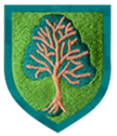
This term our topic is Fantasy Island!!

As healthy movers, we will…
Show a preference for a dominant hand.

Be increasingly independent as they get dressed and undressed, for example, putting coats on and doing up zips.

Skip, hop, stand on one leg and hold a pose for a game like musical statues.
.

As communicators, we will…
Enjoy listening to longer stories and can remember much of what happens.

Know many rhymes, be able to talk about familiar books, and be able to tell a long story.

As artists, actors and musicians,
we will…
Create closed shapes with continuous lines, and begin to use these shapes to represent objects.

Draw with increasing complexity and detail, such as representing a face with a circle and including details.

Use drawing to represent ideas like movement or loud noises.

Join different materials and explore different textures.

Sing the pitch of a tone sung by another person (‘pitch match’).

As individuals and friends, we will…
Increasingly follow rules, understanding why they are important.

Remember rules without needing an adult to remind them.

Develop appropriate ways of being assertive.

Talk with others to solve conflicts.

Talk about their feelings using words like ‘happy’, ‘sad’, ‘angry’ or ‘worried’

As mathematicians, we will…
Compare quantities using language: ‘more than’, ‘fewer than’.

Talk about and explore 2D and 3D shapes (for example, circles, rectangles, triangles and cuboids) using informal and mathematical language: ‘sides’, ‘corners’; ‘straight’, ‘flat’, ‘round’.

Select shapes appropriately: flat surfaces for building, a triangular prism for a roof etc..

Notice and correct an error in a repeating pattern.

As readers and writers, we will…
Develop phonological awareness: spot and suggest rhymes, count or clap syllables in a word,
recognise words with the same initial sound, such as money and mother

Teach children to identify initial sounds of words and objects.

Use oral blending to blend words aloud with the new sounds the children have learned

Writes some letters accurately

As explorers and investigators,
we will…
Talk about the differences between materials and changes they notice.

Continue developing positive attitudes about the differences between people.

This term our focus stories are:
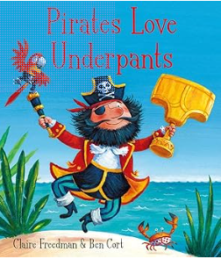
Weeks 1 and 2- Pirates love Underpants.

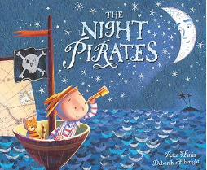
Weeks 3 and 4- The Night Pirates.

Week 5- The Pirates Next Door. 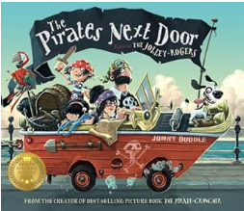

Key Vocabulary for the topic- Fantasy Island.
(Taken from Word Aware)
 | Anchor words | Goldilocks words (‘Not too easy and not too hard, but just right). | Step on words
 | Children have a thorough understanding of these words.  Everyday spoken language for a child of this age  Used at home and in daily interactions. | Really useful words  Likely to be encountered again.  Words that are very topic-specific but core to the topic. | Less likely to be encountered again.  Words that are particularly topic-specific and not core to the topic.
Nouns | Parrot  Hook  Treasure map  Captain  Treasure chest  Pirate flag  Pirate  Plank  Ship  Wooden leg  Sea  Eye patch  treasure | Desert island  compass
Verbs
Adjectives

Nursery – Summer 1- People and Differences
This half term we will be enjoying stories of People and Differences. Every day in Nursery we enjoy story time together at the end of the session. Children need to have a story read to them multiple times to really understand the story and to be able to retell key characters and events.

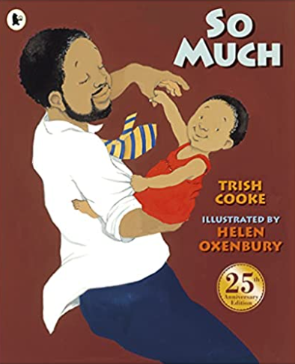 | 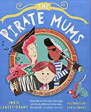 | 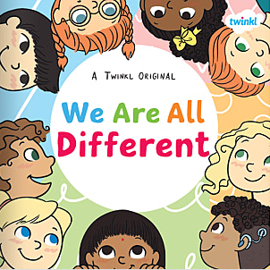
Title: So Much  Author: Trish Cooke | Title: The Pirate Mums  Author: Jodie Lancet-Grant | Title: We are all different  Author: Twinkl

