# Lumi Nova: PARENT email / newsletter For distribution to parents and guardians to introduce Lumi Nova, how to access and where to find more information

**Subject: Lumi Nova: Helping young people manage their worries**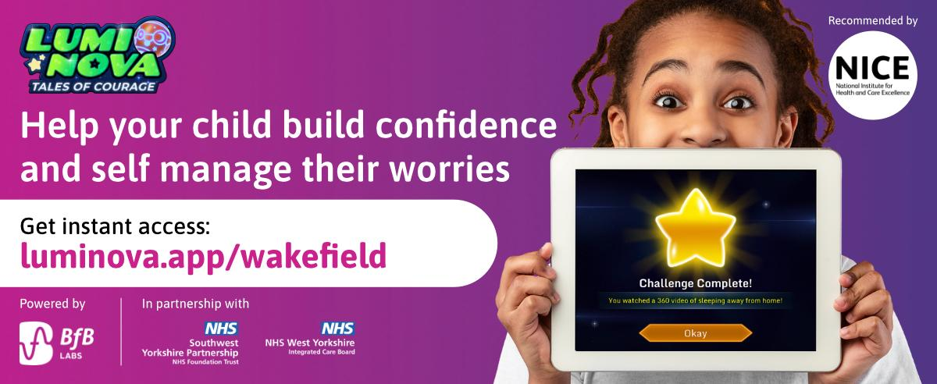

Dear parent / guardian,

We are delighted to share with you a new NHS funded service designed to support young people aged 7-12 who are experiencing worries or anxieties; **Lumi Nova**. With the end of the school year approaching, we wanted to remind you to take advantage of our offer as your child/ren transition into the summer and new academic year.

**What is Lumi Nova?**

Lumi Nova is an intergalactic adventure game to support young people to fight fears and manage worries. Whilst exploring planets, customising characters and earning treasure your child breaks their fears and worries down into manageable steps, learning life-long skills and building resilience.

Watch this short animated video to learn more: [Lumi Nova Introduction Video](https://www.youtube.com/watch?v=mmgrU4zXU3M)

**Who can use Lumi Nova?**

Lumi Nova was created for 7 - 12 year olds (school years 3 - 7) who are having difficulties with fears, worries, or anxiety related to social situations, separation or phobias.

Lumi Nova can help your child to face their worries by breaking them down into small manageable challenges and can support your child with:

* Returning to school or starting a new school
* Making new friends and going to social events
* Speaking in front of a group
* And lots more!

**How do you access Lumi Nova?**

Accessing Lumi Nova is quick and easy. Use the link below to register and you will receive a text message to guide you through getting started.

[**Luminova.app/wakefield**](http://luminova.app/wakefield)

**To find out more visit** [**luminova.app**](http://luminova.app) **or join a** [**Parent Information Webinar.**](https://www.eventbrite.co.uk/e/lumi-nova-discovery-session-for-parents-tickets-705981388337?aff=ebdsoporgprofile)

Yours Sincerely,