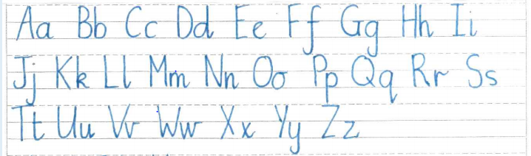We have recently changed our handwriting, both the order in which we teach our letters, how we make some of our letters and the handwriting lines we write on.

We do not teach the entrance strokes at this stage.

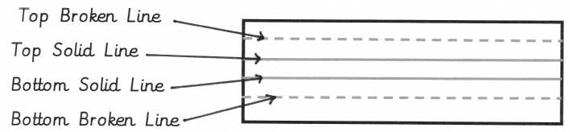

Handwriting Lines

Children are supported with different sized spaces between the lines depending on the size of their handwriting and fine motor ability. The children learn the vocabulary

* Top broken line
* Bottom broken line
* Top solid line
* Bottom solid line.

The consistency in this means that all children and adults can explain where letters begin and how they are formed.

Types of letters

Letters that reach the top broken line are referred to as ‘tall’ letters.

Letters that sit between the two solid lines are ‘short’ letters.

Those which reach the bottom broken line are ‘tail’ letters.

Here are some examples:

