South Parade Primary School

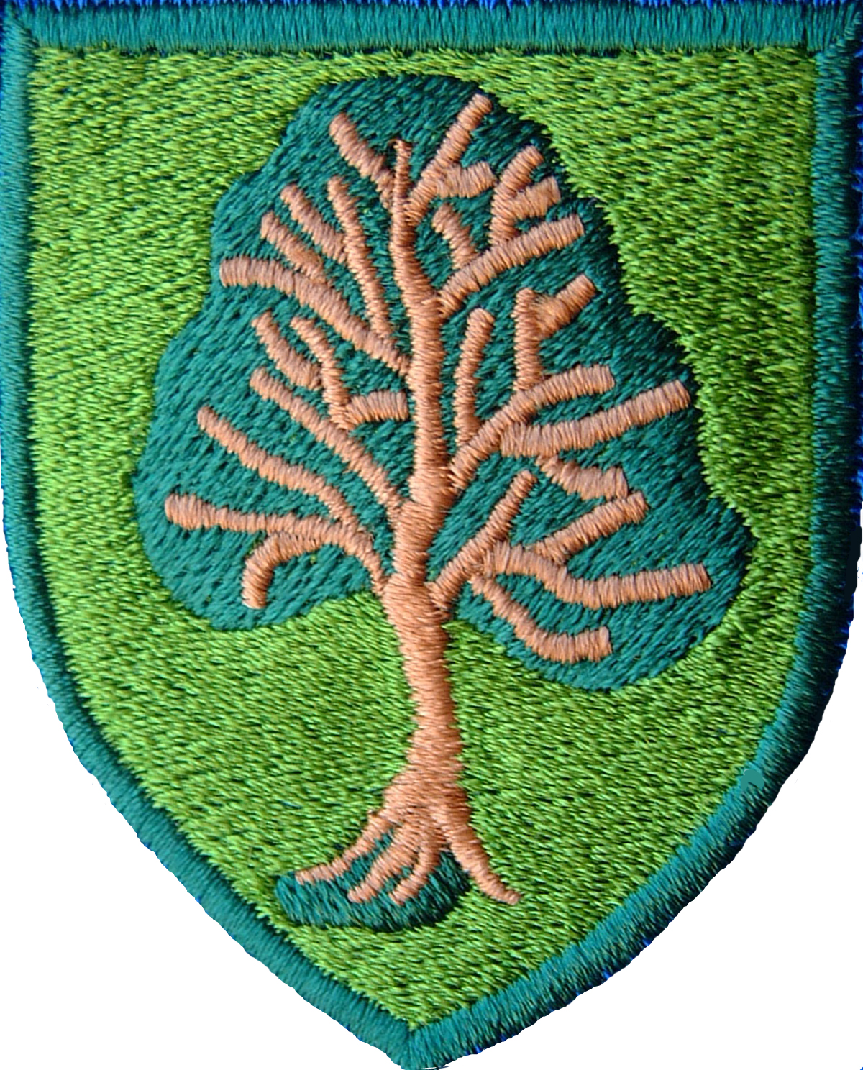

PSHRE Policy

(Personal, Social, Health and Relationships Education)

September 2026

1. Vision
At South Parade Primary School we believe PSHRE equips pupils with the knowledge, skills and values to become healthy, respectful, resilient and responsible citizens. Through the Twinkl Life PSHE scheme, updated to reflect the September 2026 DfE guidance, pupils learn how to keep themselves safe, build positive relationships and contribute positively to society.

2. Statutory Requirements
This policy reflects statutory Relationships Education, Health Education and relevant National Curriculum requirements. Teaching supports safeguarding, equality, British Values, SMSC, online safety and the Equality Act 2010.

3. Curriculum
Twinkl Life is taught weekly from Year 1 to Year 6. Units include Families and Relationships, Health and Wellbeing, Safety and the Changing Body, Citizenship and Economic Wellbeing. The 2026 updates strengthen teaching on healthy relationships, consent (age appropriate), misogyny and stereotypes, digital literacy, mental wellbeing and harmful online content. Lessons are inclusive, age appropriate and adapted for SEND learners.

4. Teaching, Assessment and Inclusion
Teachers create safe classrooms where pupils can ask questions respectfully. Learning is assessed through discussion, observation, quizzes and pupil voice rather than formal testing. Staff adapt teaching to meet individual needs using visual supports, structured language and practical activities. Parents are informed about Relationships and Sex Education and have the statutory right to withdraw from sex education elements beyond the National Curriculum.

5. Curriculum delivery
RSE is taught within the personal, social and health education curriculum. Biological aspects of RSHE are taught within the science curriculum, and other aspects are included in religious education (RE).

Lessons will be taught from the Twinkl Life programme which covers three core themes over the year with three topics per half term: Health and Wellbeing; Relationships; and Living in the Wider World. This approach allows different year groups to work on similar themes at the same time, building a spiral programme year on year, whilst offering flexibility in terms of medium term planning.

At each stage of learning, the needs of all pupils, including SEND, will be addressed prior to the delivery of lessons. Teachers will plan for all pupil groups, ensuring each lesson has appropriate content and resources to support all children.

Relationships education focuses on teaching the fundamental building blocks and characteristics of positive relationships including:
- Families and people who care for me
- Caring friendships
- Respectful relationships
- Online relationships
- Being safe

These areas of learning are taught within the context of family life taking care to ensure that there is no stigmatistation of children on their home circumstances (families can include single parent families, LGBT parents, families headed by grandparents, adoptive parents, foster parents/carers amongst other structures) along with reflecting sensitively that some children may have a different support structure of support around them (for example: looked after children or young carers).

6. Roles, Monitoring and Safeguarding
The Headteacher ensures statutory compliance. The Subject Leader, Mrs Emma Fieldhouse, monitors planning, teaching, pupil outcomes and staff development, reporting annually to governors. Governors monitor implementation. Safeguarding is embedded throughout the curriculum and all staff follow Keeping Children Safe in Education and the school's safeguarding procedures. The policy is reviewed annually.

Curriculum Principles
- Promote positive mental health and wellbeing.
- Celebrate diversity and inclusion.
- Teach respectful relationships.
- Develop resilience and independence.
- Prepare pupils for life in modern Britain.
- Work in partnership with parents.

