
South Parade Primary School
Prospectus
2026-2027


Contents

2 Vision and Core Values
3 Our Team
6 Our Space
6 Organisation of the school day
8 Parents in partnership
9 Joining our School
15 The Curriculum and other information

Welcome

We hope that you find the information that you need in this prospectus, and that it reflects some of the really fantastic things that we do here at South Parade Primary.
In my role as Head teacher, I ensure that all children are given the best chance to reach their full potential and to also ensure that they have the skills at the end of their time at South Parade to leave fully prepared for the next stage of their education. Here at South Parade we have the community, lifelong learning, spiritual, moral and cultural including British Values and eco-learning as our key drivers; we plan our curriculum to ensure that these aspects underpin the teaching and learning that we do. Our children are encouraged to explore, discover and question through a range of exciting learning opportunities both within and outside the classroom.
Although our school is quite large, we are a warm, supportive and friendly school, something we are very proud of. In fact, the biggest strength of our school is the relationships that are fostered here – it is what makes coming here each day such an enjoyable experience.
We have high expectations in terms of behaviour, personal and academic progress and enjoyment from all of us – our Staff and Governors, our Parents and, of course, our children.
If you would like any information about our school please feel free to contact us. The best way to find out about our school is to come and visit, to see us in action and meet staff and children. A telephone call to the school office on 01924 302875 is all that is needed to arrange this. We look forward to welcoming you to our school, and to a happy and successful partnership with our children and families.

Kind regards,
Rebecca Hedges, Head teacher

About our school

Key Drivers
- Eco-learners
- Aspirations for our futures
- Community

Vision
To establish a standard of excellence by supporting our pupils to develop and grow into productive citizens in our global society Core Values
At South Parade Primary School we offer an excellent start to life by ensuring that:
- Children are at the heart of everything we do
- All children have the opportunity to reach their full potential, be the best that they possibly can and be proud of who they are
- Our children are happy, well behaved, polite and have the ability to learn in any given situation
- Everyone is respected and listened to
- A caring, safe and stimulating environment is provided where learning can flourish
- Children are excellent communicators with the confidence to express themselves wherever they are
- Children are self-aware, culturally sensitive and have a strong sense of spiritual, moral and social purpose
- We celebrate differences and follow fundamental British values
- Children are responsible for their own behaviour, think for themselves and have enquiring and creative minds
- Children become active citizens who have increased life choices/chances, are life long learners and can participate in what the world has to offer them

Our team of Staff
At South Parade Primary School, our team of staff have a collective responsibility and drive to:
- To have excellent subject knowledge and first class teaching pedagogies
- To have high expectations
- To create exciting, valuable and memorable experiences inside and outside the classroom
- To embrace carefully thought out changes and have enthusiasm for new ideas, developments and technologies
- To support each other and be open to developing themselves further by constantly reflecting upon their teaching and work
- To work together to blend their different teaching experiences/styles
- To be inspirational and ensure every individual can reach their full potential
- To be outstanding role models for the children
- Have a drive for improvement



Staff at South Parade Primary School
Senior Leadership Team
Mrs R Hedges
Head Teacher, Assessment Lead, Teaching and Learning Lead, DSL
Mrs E Fieldhouse
Deputy Head teacher, KS1 Lead, Pupil Premium, ITT, CIC, PSHRE, phonics and early reading, Online Safety, Primary Futures Lead, DSL
Mrs A Fowles
SENDCO, LKS2 Leader, Mental Health Lead, DSL
Mrs N Iveson
Teaching & Learning Lead, Curriculum Lead
Mrs H Varnom
EYFS Lead, Phonics and Early Reading Lead
Mr J Morton
UKS2 Lead, Science Lead
Office Team
Mrs C Heptinstall (Business Manager)
Mrs C Basir, Mrs V Greenwood, Mrs D Prime
Learning Mentor
Mrs S Banks, DSL
Foundation Stage Team
Nursery
Miss F Stephenson, Nursery Teacher, DSL
Mrs A Earley NNEB, Miss D Ellis
Reception
Class 1
Mrs H Varnom, Class Teacher/EYFS Leader
Mrs M Ibbitson, Miss J Dixon, Mrs T Pollard
Class 2
Miss N Crowther, Class Teacher
Mrs K Beresford
Key Stage 1 Team
Year 1
Class 3
Mrs E Marsden, Class Teacher, RE Lead (Mrs Scholes Fri am, Mrs Liversidge Fri pm), Mrs V Chisem, Mrs J Bowden
Class 4
Mrs J Brealey, Class teacher, Art Lead, (Mrs J Scholes Mon)
Mrs S Fox, Mrs J Jobson, Miss L Robinson
Year 2
Class 6
Mrs J Brown, Class teacher, Maths Lead, (Mrs J Scholes Wed)
Mrs A Redgwick, Mrs J Adamson, Miss J Parker
Class 7
Mrs N Iveson, Class Teacher, Teaching & Learning Lead
Mrs B Marley
Lower Key Stage 2
Year 3
Class 8
Miss A Fabregas, Class Teacher, Music Lead
Ms S Buhary, Mrs K Cross
Class 9
Mrs L Thomas, Class Teacher
Mrs L Wilson, Mrs A Noreen
Year 4
Class 10
Miss E Sutcliffe, Class Teacher, Computing Lead
Mrs J Liversidge, Mrs S Mpofu, Mrs A Wilson, Mrs S Gill
Class 11
Miss H Schofield, Class Teacher
Mrs J Liversidge, Mrs K O’Loughlin
Upper Key Stage 2
Year 5
Class 12
Mrs D Harrison, Class Teacher, Community Lead, EVC Lead
Mrs T Hartland, Mrs J Clayton
Class 13
Mr D Lewty, Class Teacher, MFL Lead
Mrs T Hartland, Mrs A Wilson, Mrs A Wilson
Class 14
Mr J Morton, Class Teacher, UKS2 Lead, Science Lead
Mr D Brown, Mrs S Prince
Class 15
Mrs J Whiteley, Class Teacher, DT Lead
Mr D Brown, Mrs S Gill, Mrs R Allatt, Mrs M Wilkinson
HLTA
Mrs J Scholes, HLTA, Cover Supervisor – PPA and Management Time, Breakfast Club Lead
Mrs J Liversidge, HLTA, Cover Supervisor – PPA
Mrs S Prince, HLTA, Cover Supervisor – PPA
Mrs T Hartland, Acting HLTA
Mrs B Marley, Acting HLTA
Safeguarding Team
Mrs Hedges, Mrs E Fieldhouse, Mrs S Banks, Mrs A Fowles, Miss F Stephenson
Lunchtime Supervisor Team
Senor Lunch time Supervisor: Mrs L Robinson
Mrs K Cross | Mrs J Bulman
Mrs M Scott | Mrs R Stubbs
Mrs S Howard | Mrs J Roberts
Mrs T Pollard | Mrs M Wilkinson
Mrs C Kerr | Mrs L Townsend
Mrs A Noreen | Mrs S Harrison
Mrs L Wilson | Mrs K O’Loughlin
Ms S Buhary | Mrs M Ibbitson
Premises Supervisor
Mr D Doherty

Our Space

The school building is modern, spacious and on a single level, allowing excellent access to all pupils and adults. As well as our classrooms hosting children from ages 3 – 11, we also have:
A well-equipped library
A Lifelong Learning Lounge
A light room
A dedicated Cookery Room
A Design and Technology Bay
An Art Bay
A large hall
Spacious playing field
A woodland and pond area (Freya’s Garden)
Large playground space with two trim trails

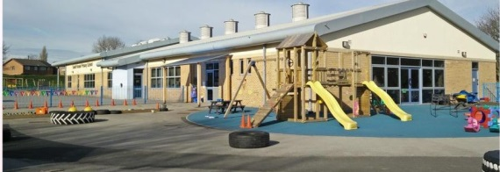
Organisation

Children are entitled to spend up to five terms in the Nursery, accessing morning or afternoon sessions (mornings: 8.50-11.50am, afternoons: 12.30 – 3.30pm) from the start of the term after their third birthday.
We have two classes in each other year group, each one taught by a qualified teacher or HLTA who is assisted by a Teaching Assistant/s. Care is taken to ensure classes are mixed in terms of age, gender, ability, behaviour, attitudes and confidence, and special educational needs. All of our teachers have half a day per week to support planning and assessment, and teachers on the Senior Leadership team receive extra time out of class to have time to cater the best education for our children.

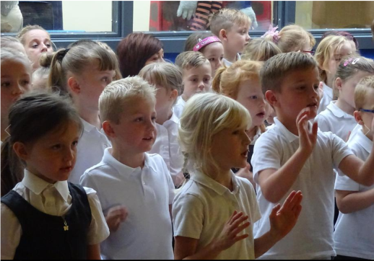

Foundation Stage
3-4 years Nursery
4-5 years Reception

Key Stage 1
5-6 years Year 1
6-7 years Year 2

Key Stage 2
7-8 years Year 3
8-9 years Year 4
9-10 years Year 5
10-11 years Year 6



The School Day

Session times:
Lower Foundation Stage (Nursery)
Morning 8.50 – 11.50
Afternoon 12.30 – 3.30

Key Stage One Key Stage Two
8:40/8.50 – 10.30 8:40/8.50 – 10.30
10.45 – 12.00 10.45 – 12.00
1.00 – 3.20 1.00 – 3.20

Assemblies
Monday 9.10 PSHRE based
Wednesday 9.10 Christ Church / singing
Friday 2.30 Celebration

Parents in partnership

Communication with parents

We communicate with parents and carers in various ways, for example through our school website, class dojo, text messages, our weekly class newsletters, questionnaires, coffee mornings and informal social events. Parents are invited to parent/child consultation evenings throughout the year. Our children are involved in writing their own termly progress reports which parents receive. Parents will also receive an end of year report for their child written by the class teacher.
Every year parents and others are invited to attend our annual Sports Day as well as children’s performances for various occasions. Staff will always be happy to meet with parents and carers to share any concerns. The school has a Home School Agreement to support the partnership between home and school, and foster shared dialogue.
We also keep parents updated with a wealth of information including newsletters, class pages, photos and key policies through our school website: www.southparade.wakefield.sch.uk
We operate a text service which ensures that we can keep parents regularly updated, send out reminders etc. We also offer every parent a log in to class dojo where teachers communicate key messages, curriculum updates and photos etc. This also operates as a messaging system.

If you have any questions, please do not hesitate to pick up the phone and contact us on 01924 302875, or alternatively you may use the contact form on the school website.

Joining our school

Admissions

The administration of admission arrangements for children starting full time school or for children wishing to join our school later on in their education is all dealt with centrally by Wakefield Council. There is a web link available through our school website. If you wish to have a paper copy of the admission arrangements, please contact the school and we will be happy to provide you with this information.
To start our school Nursery, you simply need to contact the school as soon as possible. Your child will be able to start Nursery the term after their third Birthday; you will be able to request either a morning or afternoon place. Places are allocated according to set criteria, details available on request.

Appeals

Every effort is made to make a place available for your child in our school. However, schools have a limit on the number of children they can take with planned admission numbers set out by the Local Authority and agreed with Governors and Head teacher. If the number of children wanting a place is below the set figure, your child will be offered a place. There may, however, be instances when there are too many children of that year group for them all to be given a place. If a place is not available on application you have the right to appeal to Wakefield Council Education Authority. Appeals are heard by an independent panel. A Guide to Admission Appeals can be obtained from the Admissions Team via the Wakefield Council website: www.wakefield.gov.uk

Starting school for the first time

Starting school is a very important time for you, your child and the school. We all need to work together to make the transition smooth and rewarding In the term prior to their entry, pupils are invited into school for visits. This will help them become familiar with the surroundings and routines of school.
Pupils will be admitted to South Parade Primary School in the September of the academic year in which they are five. The Early Years Curriculum is grounded in active learning. Through practical activities, purposeful play and talk, pupils develop an understanding of the world and the basic concepts they will need for their later learning. Parents can play a major role in fostering good attitudes to learning, developing language skills and promoting good behaviour. Every child deserves the best possible start in life and the support that enables them to fulfil their potential. Children develop quickly in the early years and a child’s experiences between birth and age five have a major impact on their future life chances.
Good parenting and high quality early learning together provide the foundation children need to make the most of their abilities and talents as they grow up. The Early Years Foundation Stage (EYFS) sets the standards that all Early Years’ providers must meet to ensure that children learn and develop well and are kept healthy and safe. It promotes teaching and learning to ensure children’s ‘school readiness’ and gives children the broad range of knowledge and skills that provide the right foundation for good future progress through school and life. At South Parade Primary School we value the potential of home-school links and make every effort to involve parents in the learning and development of their child.

Joining the school later on

Sometimes children join our school later on in their school life. We make every effort to ensure they are welcomed, looked after, and monitored so that they quickly make friends and can find their way around the school. Teachers give children time to settle in before making an assessment of their academic abilities. This assessment, together with records from the previous school, will enable your child to have the best start in our school. Parents and carers are asked to contact the school if their child has any difficulty settling in.

Uniform

What a child wears to school reflects his/her learning. It also portrays the school’s ethos and shared positive values. Therefore we expect that no child has an extreme hairstyle such as Mohican / braided / shaved / brightly coloured etc. Hair styles as well as the uniform are central to the ethos of the school. We don’t allow children to wear jewellery in school, apart from a watch and one pair of small stud earrings, which the children will be asked to remove during games and P.E. activities for their personal safety. Children are not permitted to wear nail varnish, and will be asked to remove it if they do.

We have a smart but simple uniform that we encourage all pupils to wear.
Black / grey trousers, skirt (to the knee), pinafore dress, culottes or shorts.
White polo shirt with or without school logo.
Royal blue sweatshirt, v necked jumper or cardigan, with or without logo.
Blue checked summer dress.
Black school shoes/ plain black trainers.

PE Kit
PE kit to be worn on the days when they have timetabled PE. We ask that all children strictly wear:
Black or navy shorts /tracksuit bottoms, a white t-shirt, and a black or navy tracksuit top. No logos please. A pair of trainers. A normal school jumper or cardigan could also be an option on PE days.
Ear-rings must be studs only (no hoops or dangly ones).
No nail polish or false nails.
Any head covering should be in school colours – black, white, royal blue or grey.
We expect ALL children to wear the correct uniform and ask that all parents/carers support us with this please.
We do have a Uniform Bank in school where we have a stock of donated uniform - please do let us know if you wish to access this and we will be happy to help.
All uniform requirements can be purchased via:
- The Uniform Centre on 01924 366633 (Wakefield) or 01924 442294 (Batley) or online at www.uniformcentre.co.uk
- The Box, Seemore Shopping Parade, 13 Towngate, Ossett, WF5 9BL. Opening Times: - Monday - Friday 9.30am to 5.15pm & Saturdays 9.30am to 5pm. Telephone 01924 263030
- My Clothing Ltd (formally UES) online at www.myclothing.com. Just enter our school name in the search section of their website. Telephone 08000 699949
- Trutex. 79 Northgate, Wakefield, WF1 3BX. Telephone 01924 299820. Opening Times: Monday – Saturday 9.30am to 5.00pm
- Smart Uniforms – The Springs, Wakefield

PE and Games Kit

Children should come to school wearing their PE kit on the days when they have timetabled PE lessons – your child’s class teacher will inform you on which days these will be.
It is important for pupils to wear correct clothing for physical activities. For PE children require a white t-shirt and black shorts. For games activities outside, children need a white t-shirt, black shorts and trainers. A plain tracksuit (black or navy without logos) may be worn for games during winter months. All clothing should be clearly labelled. Jewellery must not be worn for sporting activities and long hair should be tied back.


School Meals

Children in UFS and KS1 are provided with a free school meal under the governments’ universal free school meals scheme. For children in KS2 meals there is a daily cost which can be paid on our Parent Pay system. Meals are cooked on our premises. We use an online payment system to pay for school meals, you will be given instructions on how to set up your account. We expect good table manners and good behaviour at all times during the lunch break.
Dinners – Children have a choice of main courses and puddings that are well balanced, nutritious and varied. Children will be asked to choose their meal on entry to school each morning. A copy of the menu is available for you to view on our school website. If for any reason you cannot get your child to school for 9.20 a.m. and will require a cooked meal or a sandwich can you ring the school office before 9.20 a.m. on 01924 302875 to order your child’s choice, as this is the deadline for the school kitchen. The office team will give you the choices available or if you prefer the menu is available on our school website, it may be helpful to look at these with your child so you can make the choice together. If you cannot order by 9.20 a.m. can we please ask that you send your child with a packed lunch.
Sandwiches- Packed lunches are eaten either in the school hall or in a designated sandwich room (our Cookery room); Sandwich boxes should be clearly marked with the child’s name. We encourage children to have a healthy diet so please support this by ensuring that your child eats a healthy, balanced packed lunch and do not send sweets, chocolate bars or fizzy drinks in cans or bottles. We provide the children with water to drink. They may brink a carton of fruit juice etc.

Children are provided with fruit every day in Key Stage One as part of the government scheme. If your child is in KS2, please feel free to send your child with fruit as a snack for their break time.

All children should bring a water bottle to school every day. They will be encouraged to drink water regularly to stay hydrated. No drinks other than water will be brought into school by pupils unless recommended by a doctor for medical needs.



Safeguarding

South Parade Primary School is committed to safeguarding and promoting the welfare of children and expects all staff and volunteers to share in this commitment. Staff work hard to maintain an environment where children feel safe and secure. The curriculum is designed to ensure opportunities for children to develop the skills they need to recognise and stay safe from abuse. Children know that they can approach any of the adults in school if they are worried and that they will receive a consistent supportive response.

In recognising our responsibilities for Safeguarding and Child Protection, as a school we:
- Have clear staff recruitment and selection procedures, ensuring that all staff (including volunteers) who have unsupervised access to children, have been appropriately checked for their suitability through the DBS procedure
- Hold weekly child well-being meetings with all staff to share information where relevant
- Have robust safeguarding arrangements in place with all staff fully trained an up to date with latest contextual issues
- Aim to raise awareness of child protection issues and equip children with the skills needed to keep them safe
- Develop and implement procedures for identifying and reporting cases, or suspected cases of abuse
- Support any children who are on any form of safeguarding plan, working closely with social workers and other professionals
- Establish a safe and nurturing environment free from discrimination or bullying where children can learn and develop happily

Our safeguarding policy is available on our school website. If you would like to know more about our policy or procedures for Safeguarding, please speak to any of our designated safeguarding officers: Mrs. R Peace, Head teacher, Mrs. E Fieldhouse, Deputy Head teacher, Mrs. S Banks, Learning Mentor or Mrs A Fowles (SENDCO/ mental health lead). Our designated safeguarding Governor is our Chair of Governors, Mrs. B. Riley.


Catering for the needs of all children

At South Parade Primary School we believe that every child is unique and special, and we aim to provide a broad and balanced curriculum for all. We are committed to developing cultures, policies and practices that are inclusive. We have systems to identify when children have barriers affecting their learning and tailor specific interventions to enable pupils to overcome their barriers. This practice of personalising learning applies to all pupils across the learning spectrum.

We have a wide range of interventions run by our SEND TA’s or specialist

Work for all children is well planned, challenging and differentiated appropriately and the whole-school curriculum is planned to provide exciting and creative learning opportunities. Expectations are consistently high across the school and children are encouraged to be independent thinkers and learners, and to have enquiring minds. Where children are identified as needing additional learning or behavioural support, the school adheres to the SEND Code of Practice. We ensure that each child’s needs are individually and appropriately catered for, and that any relevant outside agencies are involved in providing guidance and support. Through assessments and/or observations a teacher may feel a child needs to be placed on the Special Needs Register. With the lead from Mrs. Fowles, our Special Educational Needs (SEND) Co-ordinator, provision is carefully planned. Provision strategies to help support the child in class and notes from discussions with parents form a ‘One Page Profile.’ The SEND Co-ordinator is responsible for supporting, planning and monitoring interventions and pupil profiles. This monitoring is used to ensure systems are effective and impact positively on pupil progress. Following discussions with parents and carers, pupils may be placed onto the SEN Register at some point in their school career. For many, this involves a short burst of targeted intervention which may lead to them being removed again, while for others the support process is a longer one. In all cases our aim is to provide the very best education for pupils, allowing all children to fully achieve their potential. Our SEND policy along with the SEND information report is on our school website. Mrs Fowles is also our Mental Health Lead in school.
If you have any queries please do not hesitate to contact Mrs. Fowles.



The Curriculum

The School curriculum comprises all learning and other experiences that we plan for our pupils. The curriculum of the school is organised so that children are stimulated, encouraged and challenged to develop their individual potential and personality to the full. At South Parade Primary our curriculum comprises all the learning and other experiences that we plan to meet the needs and interest of our pupils. It is constantly evolving to develop the skills needed for children to become successful learners, help prepare them for life in modern Britain and empower them to achieve success in the future. Our aim, to deliver a dynamic and innovative curriculum that challenges, excites and inspires children to become successful and confident learners and achieve their best, is the main driving force behind how we design and deliver our curriculum. Our key drivers which underpin our curriculum are lifelong learning, eco learning and community.
The school’s curriculum promotes and sustains a thirst for knowledge and understanding, and a love of learning. It covers a wide range of subjects and provides opportunities for academic, technical, creative and sporting excellence.
You will see details of each subject on our school website under the curriculum section which details subject maps and curriculum coverage.
We have whole school theme days / weeks such as Diversity week, Healthy week and Science week, Anti-bullying themed day, e-safety awareness day, annual Spelling Bee and Great South Parade Bake Off, SP Fest, as well as enterprise projects such as children in charge of organising the annual summer fayre.
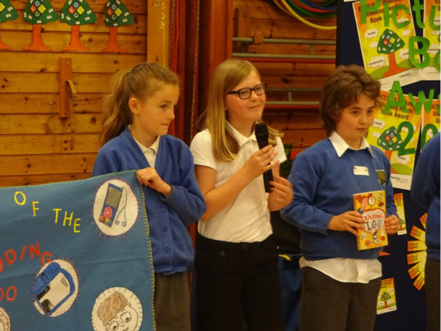
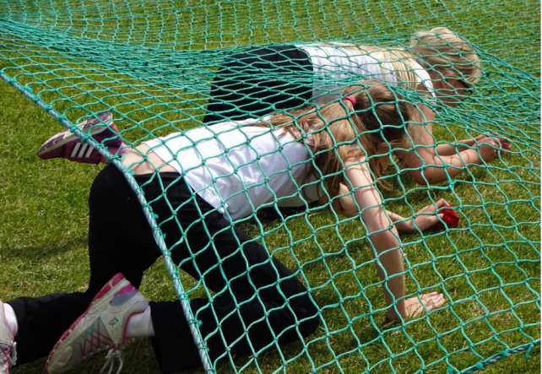
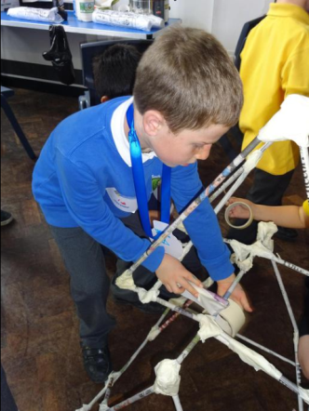
Attendance

At South Parade Primary School, we actively encourage children to attend school and discourage parents from taking children out of school for holidays (unless there are exceptional circumstances) so that they do not miss vital parts of their education.
Parents who choose to take holidays during term time should be aware that through Wakefield Local Authority, if over four and a half days will be subject to a fixed penalty notice.

Reporting illness / absence

If your child is unwell, please contact school on our dedicated absence line
01924 302875
This number is an answer machine service which will be picked up by one of our administrative staff when the office is open. You may however leave a message at any time of the day or night as it helps us to know as soon as possible.
If your child’s absence is unreported, you will expect a text, and if we have no response a phone call, to establish a reason for absence. If we cannot get in touch with yourselves, we will contact your emergency contacts, in line with our attendance policy.
If your child is at school and becomes unwell, you will receive a phonecall and will be asked to collect your child. In the case of sickness or diarrhoea we ask that you keep your child off school for a period of 48 hours in order to prevent this from spreading to other children. If your child has headlice, once treated your child is permitted in school. If we see a live head louse, you will be contacted to collect your child in order to start treatment.

Medical needs

If your child is attending school and requires medicine (prescribed by the doctor), then we would prefer the medication to be administered by the parent, however if this is not possible the smallest practicable dose should be brought to school, by an adult, with the child’s name on the medicine. It will be kept in the medical room and administered under the supervision of an adult. You will be asked to fill in a drugs administration form requesting us to give the medicine and stating the time and dosage etc. Any medication given is recorded in our medical book. Due to legal implications we are unable to administer medication purchased without a doctor’s prescription.

When your child joins our school, you will be asked to complete a form where you will identify any medical needs of your child. We ask that you keep us updated throughout your child’s journey here, on any changes or anything that we should be aware of. If your child has asthma and has been prescribed with an inhaler, we must have one in school (in date).



Essential
Information

Contacts

Address: Fairfield Road
Ossett
West Yorkshire
WF5 0DZ

Telephone: 01924 302875

Website: www.southparade.wakefield.sch.uk

Contact: admin@southparade.wakefield.sch.uk

Head teacher: Mrs. Rebecca Hedges

Deputy Head teacher: Mrs. Emma Fieldhouse

Chair of Governors: Mrs Laura Hebblethwaite

