South Parade Primary School

Children’s Safeguarding Policy
Feeling safe and happy at school
At South Parade Primary School, we want to make sure that you feel looked after, safe and happy when you are in and out of school.
Sometimes we don’t know if something bad is happening, so you need to tell us.
This booklet, which is known as a “policy”, looks at what we do to make sure you are kept safe, and what you can do when you think someone is hurting you or someone else.
We can help you by:
• Teaching you what safeguarding is.
• Teaching you what to do if you feel worried or scared.
• Making sure you know who you can speak to if you are worried.
If you don’t understand something or have any questions about what you read in the policy, please ask your teacher for help.
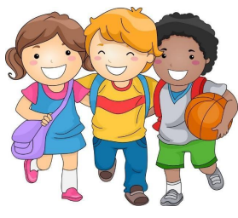

What does safeguarding mean?
“Safeguarding” refers to all the things we do to make sure you are kept safe from any
harm.
Safeguarding means that staff will:
• Protect you from harm.
• Make sure that nothing stops you being healthy or developing
properly.
• Make sure that you are looked after.
• Make sure that you have the best life chances and can grow up
happy and successful.
We will make sure that the school is a friendly, welcoming and supportive place to
spend time in, making it somewhere you want to be.
We want to make sure that you know who to ask for help, and will plan lessons to
help you know how to look after yourself online and in the real world.


Staying safe
If you are worried about something, you can talk to any adult in school that you trust.
This could be your teacher or any other staff member. If you need to talk, we will
listen.
We respect you and want to keep you safe, so we will do our best to
help you to feel safe and happy. We will also teach you how to spot
risks and what you can to do keep yourself safe.
We think it is important for you to know where to get help if you are
worried or unhappy about something, and we will do our best to spot
if there is a problem.
We will always make time to listen and talk if you need us, please remember:
• You are important to us.
• It's never your fault if someone is hurting you.
• There is always someone that can help you and you will not be in trouble.
• If someone is hurting you, they may also be hurting someone else, so it is
important that you tell someone to make it stop and know that you will be kept
safe.
• Every child should enjoy the right to a happy and safe childhood – do not be scared
to tell someone if there is anything worrying you.



Who to talk to
It’s important that you tell someone you trust if someone is:
• Bullying you.
• Saying things to you that make you feel upset or uncomfortable.
• Touching a private part of your body.
• Hitting or hurting you.
• Taking your things.
• Sending unkind messages on the internet or to your phone.
It is important you tell someone as soon as someone starts hurting or harming you,
or you think that this is happening to someone else.
Speaking to someone like your parent, carer or teacher will mean that we can make
sure the abuse stops and doesn’t happen again.
In every school there is always somebody who has the responsibility to keep you safe
and all staff have to tell that person if they are worried about you – this person is
called the DSL, which stands for designated safeguarding lead. Other members of
staff have also been taught how to do the DSL’s job.
Staff are taught how to keep children safe as it is the most important part of their
job.
The list below shows the people at our school that can do the job of the DSL:
• Mrs Hedges, Mrs Fieldhouse, Mrs Banks & Mrs Fowles
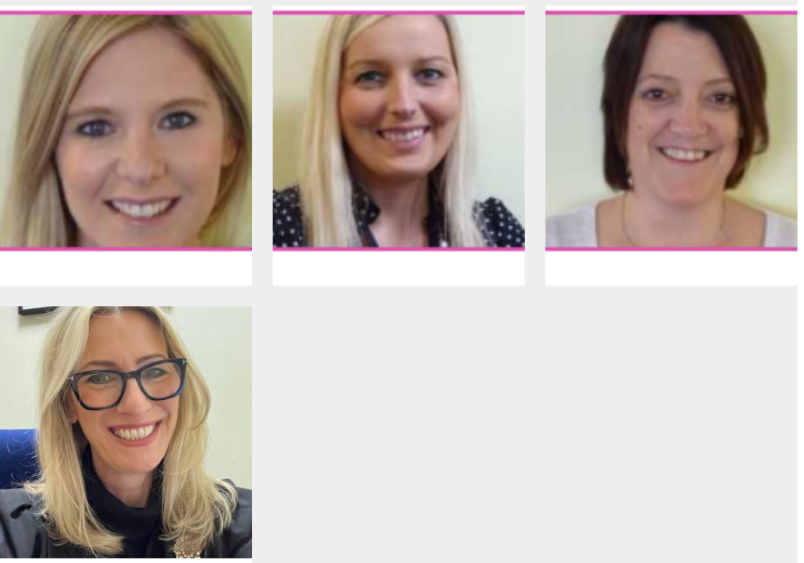
There are also places outside of school that you can go to for
help. You can call or visit:
• Childline on 0800 11 11 or visit www.childline.org.uk
• NSPCC on 0800 800 5000 or visit www.nspcc.org.uk
• Kidscape on 020 7730 3300 or visit www.kidscape.org.uk
• Youth Access on 020 8772 9900 or visit www.youthaccess.org.uk



Bullying
Bullying is a type of abuse that takes place when someone tries to hurt another
person on purpose for a prolonged period of time. People can be bullied in many
different ways:
Emotional bullying includes hurting someone’s feelings, by leaving them out or
bossing them about. People can sometimes use emotional bullying to take
advantage of you to get their own way by making threats or making you feel like you
have to do something for them.
Physical bullying can include hitting, kicking, shaking, biting, hair pulling or purposely
hurting someone.
Verbal bullying can include insulting someone because of how they look or because
of their personality, and can often go beyond that. People can also use verbal
bullying to be racist, sexist or homophobic.
Racist bullying is bullying someone because of their race, skin
colour, the country they are from or the religion they believe in.
Homophobic bullying means bullying someone because of their
sexuality; calling someone gay or lesbian to hurt their feelings
would be homophobic.
Sexist bullying is bullying someone because of their gender;
bullying someone because they are a boy or a girl would be sexist.
Cyberbullying includes any kind of bullying which takes place online; cyberbullies
send insulting messages over the internet and sometimes share secret information
online to hurt someone’s feelings.
Bullying is not always done by one person and can often involve a group of people
‘ganging up’ on someone – if you ever see someone being bullied, never join in and
always tell a teacher.
The bully could be one of your peers, an older or younger child or an adult. It’s
important that you tell someone if you think you are being bullied.


Internet safety
Internet safety is an important part of keeping children safe at our school. We have
lots of safety measures in place which we keep an eye on both in and outside of
school, to help safeguard children.
Computers and mobile phones help us all to share things
and talk to friends or family, but they can also make it
easier for bullies and other people to hurt you or to get
close to you. It is important to know how to keep
yourself safe on your computer, your phone and on
websites.
The school will help if you are sent unkind messages or if someone on the internet
has asked you to do anything that has made you feel uncomfortable.
If you are unhappy with any comments or photographs you've seen on your
computer or mobile, you can tell a staff member in school.
We have an Online Safety Policy which is there to protect you.


Relationships
Any relationship you have should be positive and make you feel safe, happy and
comfortable. A negative relationship might make someone feel scared, confused,
worried and even unsafe.
It is really important that you know the difference between a positive relationship
and a negative relationship.
Positive relationships
• You are comfortable around that person.
• You can be honest with that person.
• You can say how you feel and what you are
thinking, and you listen to each other.
• You support each other and treat each other well.
• You feel safe.
• You trust that person.
• You do helpful things for each other.
• You are never pressured to do anything that makes you feel uncomfortable.
• You feel looked after

Negative relationships
• The person might push you, hit you or break your things.
• The person might tell you what to do, what to wear or who you can see.
• You might feel scared – they might say they will hurt you
if you don’t do something.
• The person might make threats or do harmful things if
you do something they did not want you to do.
• The person calls you names, makes you feel bad in front
of other people and makes you feel bad about yourself.
• The person gets angry easily and you don’t know what
will make them angry – it might make you feel nervous.
• The person might pressure you to do things you don’t want to do or are not ready
for.
• The person might not take no for answer when you say you don’t want to do
something.


School buildings and the playground
All school staff will do their best to make sure the building
is safe for you to learn in and spend time in.
We will make sure that you know who everyone is in
school by asking visitors to sign in when they arrive at
school. You will always know who a visitor to the school is
because they will have a lanyard or badge to wear.
If you see someone acting suspiciously or trying to gain access to school grounds you
should report this to a teacher.
People that we do not know will never be allowed to spend time with you on your
own and they will not be allowed to walk around the school without a member of
staff.

