

Safeguarding Guide for visitors to our school
Welcome to South Parade Primary School.
We are committed to safeguarding and promoting the welfare of children. As such we expect all staff, volunteers and visitors to share this common commitment. This leaflet is a guide to our safeguarding procedures which are detailed in our Safeguarding policy (available to view on the school website and on the staffroom noticeboard). Please keep the leaflet in a safe place so that you can read it again if you need to. We hope you enjoy your time at our school. If you are unsure about anything, please ask.
If you feel that a child may be at risk of harm but are not sure, then inform one of the Safeguarding team immediately. They will offer advice and take appropriate action.
The Safeguarding Team
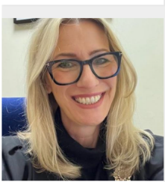
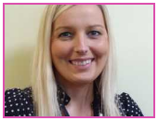
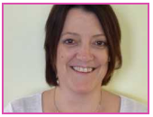
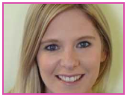

Mrs Rebecca Hedges Mrs Suzanne Banks Mrs Emma Fieldhouse Mrs A Fowles
Head Teacher Learning Mentor Deputy Head Teacher SENDCO

If a child discloses they might be subject to abuse:
•React calmly
• Listen carefully to the child, particularly what is said spontaneously.
• Do not promise confidentiality. Explain to the child that you must pass on the information if you are worried about their safety.
• Do not ask leading questions or make judgements. Clarify and check your concern if you feel that you are not sure, by using, for example, ”tell (T), explain (E), describe (D)” but as soon as you believe that there might be a genuine issue, ask no further questions. This would compromise further enquiries. Only trained investigators should question a child. Reassure the child that they are doing the right thing.

Any disclosure from child, or any concern, please report to a safeguarding officer, or the class teacher in the class you are working in, they will then record this on CPOMS with you present. It will then go to the safeguarding team on CPOMS. If you are unsure whether the concern should be reported, please do so anyway – this may be information that is part of a bigger picture for that child.

Child abuse can happen to any child regardless of elements such as gender, culture, religion, social background ability or disability.
We all have a responsibility to keep children (under the age of 18) safe, both at home and in school. Harm is identified in four ways:
Physical - when a child is deliberately hurt or injured.
Sexual - when a child is influenced or forced to take part in a sexual activity. This can be a physical activity of no-physical, e.g. being made to look at an inappropriate image.
Emotional - when a child is made to feel frightened, worthless or unloved. It can be by shouting, using threats or making fun of someone. It can also be when children see their parents, or visitors to the home, fighting or using violence.
Neglect - when a child is not being taken care of by their parents/ guardians. It can be poor hygiene, poor diet, not keeping appointments for additional support, not coming to school are being left home alone.
REMEMBER...if in doubt...ask.
Please do not leave our school without telling someone or doing something.

